The title should be concise, and explanatory and represent the content of the work. The title must have only the first letter of the sentence in uppercase. Acronyms, abbreviations, geographical location of the research, en or em dashes (which must be replaced by a colon) are not allowed. Titles do not have periods.

Please, do not inform the authors' names, affiliations, and acknowledgements, since EQJ uses a double-blind review system.

**ARTICLE INFO**

***Keywords* (3 to 5)**

1. one

2. two

3. three

4. four

5. five

***Highlights* (3 to 5)**

1. one

2. two

3. three

4. four

5. five

**ABSTRACT:** The abstract is the summary of the article. As such, the academic literature uses the abstract to succinctly communicate complex research. The abstract must be written as a running text not as structured topics, but its content should present background, objectives, methods, results, and conclusion. It cannot contain citations. The text should be written in a single paragraph with a maximum of **170 words**. Font Times New Roman, size 10. Please, delete this text and insert your abstract.



The graphical abstract is mandatory for this journal. It must summarize the manuscript in an interesting way to catch the attention of the readers. As already stated, it must be designed with 5 cm wide × 11.5 cm high, and a 300-dpi resolution. It must be submitted as *.jpg, *.jpeg, *.tif or *.ppt files as supplementary file.

**1. Introduction**

Text.

**2. Experimental**

***2.1 Reagents and solutions***

Text.

***2.2 Instrumentation***

Text.

***2.3 Preparation of microparticles***

Text.

Equations must be written with the Equation tool provided by Microsoft Word or LibreOffice Write. You must cite them in the text, right before their first appearance, such as Eq. 1:

$\text{EE }\left(\text{\%}\right)\text{= }\frac{\left(X_{o}\text{ - }X_{f}\right)}{X_{o}}\text{ × 100\%}$ (1)

where: you can specify your Equation variables.

**3. Results and discussion**

Figures, tables, and equations must be written with an initial capital letter followed by their respective number and period, in bold, without adding zero “Table 1”, preceding an explanatory title. Tables, Figures and Equations should appear after the first citation and should be numbered according to the ascending order of appearance in the text (1, 2, 3...).

Figures, tables, schemes, and photographs already published by the same or different authors in other publications may be reproduced in manuscripts of Eclética Química only with permission from whoever holds the copyright.

Nomenclature, abbreviations, and symbols should follow IUPAC recommendations.

**Table 1.** Title here.

|  |  |  |  |  |  |  |
| --- | --- | --- | --- | --- | --- | --- |
| **Title** | **Title** | | | **Title** | | |
| **A** | **B** | **R** | **A** | **B** | **R** |
| N | 0.3906 | 0.2468 | 0.9987 | 0.4044 | 0.4262 | 0.9972 |
| P | 1.0261 | 0.0040 | 0.9987 | 1.0117 | 0.0025 | 0.9984 |
| K | 0.0586 | 0.0028 | 0.9990 | 0.0577 | 0.0018 | 0.9993 |

Acronyms and abbreviations information.

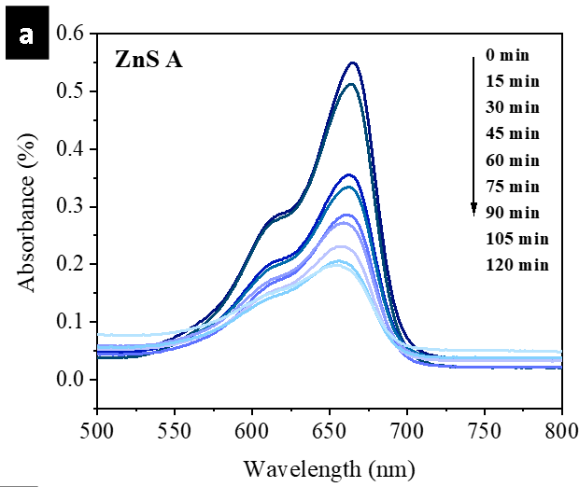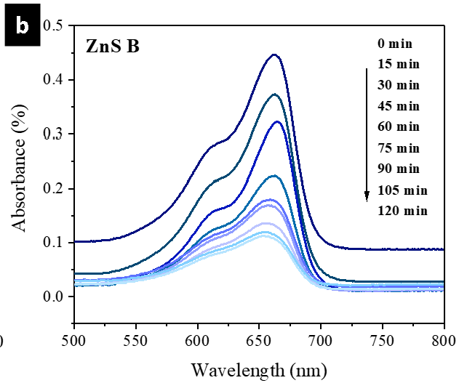

**Figure 1.** Title here. **(a)** description; **(b)** description.

**Source:** This image by an unknown author is licensed under CC BY-NC-ND.

Dear authors,

Please inform the authorship of every Figure/Table.

If made by the authors, adapted, or taken from somewhere, also include the reference citation used.

For Figures/Tables, used without modification it is necessary to inform if you have permission to use it or if it is free access.

Ex.:

Source: Elaborated by the authors.

Source: Elaborated by the authors using data from Silva (2020).

Source: Retrieved from Silva (2020).

Source: Adapted from Silva (2020).

**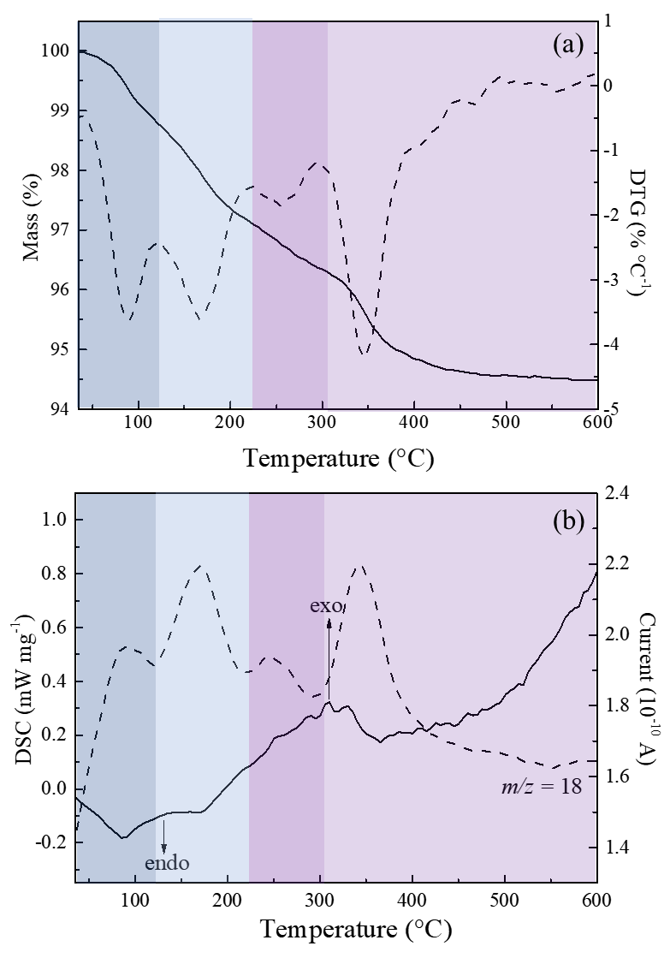****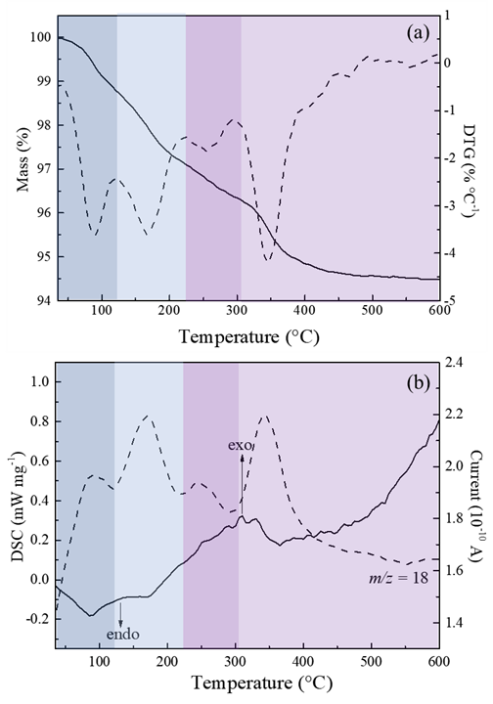**

**Figure 1.** Title here. **(a)** description; **(b)** description.

**Source:** Elaborated by the authors.

Dear authors,

Please inform the authorship of every Figure/Table.

If made by the authors, adapted, or taken from somewhere, also include the reference citation used.

For Figures/Tables, used without modification it is necessary to inform if you have permission to use it or if it is free access.

Ex.:

Source: Elaborated by the authors.

Source: Elaborated by the authors using data from Silva (2020).

Source: Retrieved from Silva (2020).

Source: Adapted from Silva (2020).

**4. Conclusions**

Text.

**At the end of the main text the authors must inform:** Has this article supplementary information?

**References (in alphabetical order)**

**For more information, you can access the** [**ACS Style Quick Guide**](https://pubs.acs.org/doi/full/10.1021/acsguide.40303) **and the** [**Williams College LibGuides**](https://libguides.williams.edu/citing/acs)**.**

*ACS Publications Home Page*. https://pubs.acs.org/ (accessed 2019-02-21).

American Chemical Society, Committee on Chemical Safety, Task Force for Safety Education Guidelines. *Guidelines for Chemical Laboratory Safety in Academic Institutions*. American Chemical Society, 2016. https://www.acs.org/content/dam/acsorg/about/governance/committees/chemicalsafety/publications/acs-safety-guidelines-academic.pdf (accessed 2019-02-21).

American Chemical Society. Game of Thrones Science: Sword Making and Valyrian Steel. *Reactions*. YouTube, April 15, 2015. https://www.youtube.com/watch?v=cHRcGoje4j4 (accessed 2019-02-28).

Department of Commerce, United States Patent and Trademark Office. Section 706.02 Rejection of Prior Art [R-07.2015]. *Manual of Patent Examining Procedure (MPEP)*, 9th ed., rev. 08.2017, last revised January 2018. https://www.uspto.gov/web/offices/pac/mpep/s706.html#d0e58220 (accessed 2019-03-20).

Foster, J. C.; Varlas, S.; Couturaud, B.; Coe, J.; O’Reilly, R. K. Getting into Shape: Reflections on a New Generation of Cylindrical Nanostructures’ Self-Assembly Using Polymer Building Block. *J. Am. Chem. Soc*. **2019**, *141* (7), 2742−2753. https://doi/10.1021/jacs.8b08648

Hammond, C. Crystal Symmetry. In *The Basics of Crystallography and Diffraction*, 4th ed.; International Union of Crystallography Texts on Crystallography, Vol. 21; Oxford University Press, 2015; pp 99−134.

Hammond, C. *The Basics of Crystallography and Diffraction*, 4th ed.; International Union of Crystallography Texts on Crystallography, Vol. 21; Oxford University Press, 2015.

Lois-Caballe, C.; Baltimore, D.; Qin, X.-F. Method for Expression of Small RNA Molecules within a Cell. US 7 732 193 B2, 2010.

*Mom the Chemistry Professor: Personal Accounts and Advice from Chemistry Professors Who Are Mothers*, 2nd ed.; Woznack, K., Charlebois, A., Cole, R. S., Marzabadi, C. H., Webster, G., Eds.; Springer, 2018.

Nilsson, A.; Petersson, F.; Persson, H. W.; Jönsson, H. Manipulation of Suspended Particles in a Laminar Flow. In Micro Total Analysis Systems 2002, Proceedings of the μTAS 2002 Symposium, Nara, Japan, November 3−7, 2002; The Netherlands, 2002; pp 751−753. https://doi.org/10.1007/978-94-010-0504-3_50