Biosynthesis of tetrahydrobenzofuran neolignans in somatic embryos of *Ocotea catharinensis*

Érica Luiz dos Santos1**[](https://orcid.org/0000-0001-9266-1786)**, Eny Iochevet Segal Floh2**[](https://orcid.org/0000-0001-6529-2065)**, Massuo Jorge Kato1+**[](https://orcid.org/0000-0002-3315-2129)**

1. University of São Paulo, Institute of Chemistry, São Paulo, Brazil.

2. University of São Paulo, Institute of Biosciences, São Paulo, Brazil.

+Corresponding author: Massuo Jorge Kato, Phone: +55 11 30911886, Email address: [massuojorge@gmail.com](mailto:massuojorge@gmail.com)

**ARTICLE INFO**

*Article history:*

**Received:** September 20, 2021

**Accepted:** February 11, 2022

**Published:** August 17, 2022

*Section Editor:* Assis Vicente Benedetti

*Keywords*

1. Lauraceae

2. *Ocotea catharinensis*

3. somatic embryos

4. 13C labelling

5. phenylpropanoids

1. **Preparation of substrates used in incorporation reactions and enzymatic assays**
2. Substrates were first synthesized with reagents not labeled with carbon thirteen and used in in vitro enzyme conversion assays, while those enriched with 13C were used in incorporation reactions in somatic embryos of *O. catharinensis*.
3. **1. Synthesis of [8-13C]-ferulic acid**
4. The [8-13C]-ferulic acid was prepared by Knoevenagel condensation between [2-13C]-malonic acid and vanillin catalyzed by aromatic amines (Katayama *et al.*, 1992). In a 125 mL flask equipped with magnetic stirring and reflux condenser, 642 mg (3.08 mmol) of [2-13C]-malonic acid, 878 mg (5.77 mmol) of vanillin dissolved in 3.5 mL of pyridine, one drop of piperidine and one drop of aniline previously distilled were added. The reaction mixture was refluxed in a silicone oil bath at 60 °C for 24 h, then for further 1 h at 100 °C and cooled to room temperature. This preparation was carried out twice. The suspension was solubilized in 15 mL of water at 80 °C, cooled to room temperature and acidified with HCl (pH 1-2). The resulting opaque solution was extracted with ethyl acetate (3 x 50 mL), the organic phases were combined and concentrated to ca. 25 mL volume and extracted with 5% NaHCO3 solution (2 x 50 mL). The aqueous fractions were combined and extracted with dichloromethane (4 x 20 mL) to remove unreacted vanillin, acidified with HCl (until pH 1-2) and extracted with ethyl acetate (3 x 50 mL). The ethyl acetate phases were extracted with saturated NaCl solution (80 mL), dried with anhydrous Na2SO4 and evaporated, yielding [8-13C]-ferulic acid crystals (973 mg, 81.0%) which was confirmed by 1H and 13C NMR spectra. The final product, about 2.0 g, was used without purification.
5. **2. Preparation of [8-13C]-coniferyl alcohol**
6. In a round bottom flask containing porcelain beads, 1.5 g (7.72 mmol) of [8-13C]-ferulic acid, prepared previously as described in item 3.4.1, dissolved in 90 mL of methanol and 300 µL of concentrated sulfuric acid. The temperature was increased before reflux began, with the reflux solvent dried continuously via a Soxhlet extractor containing CaCl2 and blue bulk silica gel. After 9 h of reaction, the mixture was cooled to room temperature, neutralized with 6.0 g of NaHCO3, filtered and evaporated to dryness in a rotavaporator. The resulting residue was transferred to a 250 mL separatory funnel, solubilized in 70 mL dichloromethane and 50 mL distilled water. The aqueous phase was again extracted with dichloromethane (3 x 70 mL). The organic phases were combined, evaporated to 25 mL and extracted with 70 mL of saturated NaCl solution, dried over Na2SO4 and evaporated under reduced pressure. 1.48 g (92.5%) of the product were obtained and identified by 1H NMR and 13C NMR spectra. The product was used without purification.
7. 500 mg (12.54 mmol) of LiAlH4 solubilized in 15 mL of dry ethyl ether were added to a 100 mL three-neck flask, equipped with magnetic stirring, addition funnel, septum and under nitrogen atmosphere, at -25 °C. A solution of 479.26 mg (12.53 mmol) of [8-13C]-methyl ferulate diluted in 15 mL of dry ethyl ether was added dropwise to the solution under stirring for about 40 min. The mixture was stirred for 1 h at -25 °C and accompanied by TLC, hexane:ethyl acetate 7:3. After this period, the flask containing the reaction mixture was transferred to a 400 mL beaker containing crushed ice and 5 mL of ethyl acetate was slowly added to the flask to destroy excess LiAlH4. The resulting solution was transferred to a 125 mL separatory funnel, added 50 mL of ethyl acetate and distilled water which was added slowly to cause the formation of precipitated lithium salt. The solution was filtered, and the aqueous phase was washed with ethyl acetate (3 x 50 mL) to extract the lithium salt. The organic phases were combined, extracted with 50 mL of saturated NaCl solution, filtered over Na2SO4, dried on a rotary evaporator, providing 398 mg (79.6%) of the crude product. Part of the [8-13C]-coniferyl alcohol was applied to a prep-TLC and eluted with CH2Cl2:EtOH 97:3 twice. The fraction corresponding to [8-13C]-coniferyl alcohol was extracted from silica with acetone. The pure product was confirmed by 1H NMR and 13C NMR spectra.
8. The protocol was performed according to a procedure described (Mohri *et al.*, 2003). In a 100 mL round bottom flask, a solution containing 22 mL of chloroform, 2.0 g (13.11 mmol) of vanillin, 2.69 g (8.82 mmol) of acetobromoglucose was added and 2.14 g (6.53 mmol) of tetra n-butylammonium bromide (Bu4NBr). Then, at room temperature, under stirring, 22 mL of NaOH (1.0 mol L–1) were added. The resulting mixture was stirred vigorously for 1 h at room temperature and, accompanied by TLC, hexane:EtOAc (7:3), until the starting reagent was completely consumed. The resulting solution was extracted with ethyl acetate (2 x 30 mL) and the organic phases combined, washed with NaOH solution (1.0 mol L–1), saturated NaCl solution, dried with anhydrous Na2SO4 and evaporated to dryness in rotary evaporator. The product obtained was recrystallized from ethanol providing 2.85 g (43.6%) and identified by 1H NMR and 13C NMR.
9. The methodology used in this reaction was developed according to a procedure described (Stöckigt and Klischies, 1977). The acetylated acid was prepared through the Knoevenagel condensation reaction. In a system set up according to item 3.4.1, 100 mg (0.961 mmol) of [2-13C]-malonic acid, 949.88 mg (1.05 mmol) of glycoacetyl vanillin were added to a 100 mL flask, 3.5 mL of pyridine, one drop of piperidine and one drop of aniline previously distilled. After the reaction time, the reaction mixture was diluted with 2.0 mL of Milli-Q water and 500 µL of acetic acid. The acetylated acid was recrystallized from 95% ethyl alcohol, yielding 904.32 mg (93.5%) of pure product. Tetra-O-acetyl-β-D-glycopyranosyl [8-13C]-ferulic acid was identified by 1H NMR and 13C NMR spectra.
10. The deacetylation of tetra-O-acetyl-β-D-glycopyranosyl [8-13C]-ferulic acid was performed according to a procedure described (Mohri *et al.*, 2003) with some modifications. In a 100 mL round bottom flask, a solution of tetra-O-acetyl-β-D-glycopyranosyl [8-13C]-ferulic acid (500 mg, 0.953 mmol) in 5% NH3-MeOH (50 mL) was added). The solution was stirred for 2 h at room temperature and followed by C18 silica TLC, MeOH:H2O (1:1), until the starting material was completely consumed. The reaction mixture was concentrated under reduced pressure in an exhaust hood and then extracted with water (20 mL) and ethyl acetate (20 mL) (in the aqueous phase it contains the glycosylated product and in the organic part of the product that did not glycosylate). The respective phases were concentrated in a rotaevaporator. The residue from the aqueous phase (280 mg) was solubilized in methanol, drops of Milli-Q water and then applied to a C18 silica chromatographic (CC) column, eluted with 1:1 MeOH:H2O. Fractions containing the product were combined and evaporated in vacuum, providing 213 mg (62.7%) of pure product. 1H and 13C NMR spectra confirmed the structure of [8-13C]-glycoferulic acid.
11. **3. Preparation of [8-13C]-coniferyl acetate**
12. The preparation of this precursor was developed in four steps according to a procedure described (Bastos *et al.*, 2005; Koeduka *et al.*, 2006). Methyl [8-13C]-ferulate (500 mg, 2.40 mmol), tert-butyldimethylsilane chloride (434.07 mg, 2.88 mmol, 1.2 eq) and imidazole (326 mg, 4.8 mmol, 2 eq.) were added into a 50 mL round bottom flask. The open balloon was placed inside a beaker, surrounded by vermiculite, and the set was placed inside a conventional microwave oven. The reaction mixture was heated for 2 min at a power of 90 W and after a cooling period (2-3 min), the reaction mixture was heated again at 180 W power. The reaction was followed by TLC, hexane:EtOAc (7:3), until the methyl [8-13C]-ferulate was fully consumed. The reaction was terminated by adding 15 mL of Milli-Q water, followed by extraction with ethyl ether. The organic phases were combined, dried over Na2SO4, and evaporated under reduced pressure. This methodology was carried out in two steps starting from 500 mg and 450 mg of methyl [8-13C]-ferulate. The crude product was purified by chromatotron, eluting with hexane:EtOAc (7:3) resulting in 1.21 mg (82.3%) of pure product which was identified by 1H NMR and 13C NMR.
13. In a three-neck flask containing magnetic stirring, addition funnel, septum and under nitrogen atmosphere were added, at room temperature, 1.0 g (3.11 mmol) of the ester prepared in step 1 (item 3.4.4) and 30 mL of dry THF distilled under metallic sodium and benzophenone. The reaction mixture was cooled to 0 °C in an ice bath and stirred for 30 min. After this period, 30 mL of diisobutylaluminum hydride in THF (DIBAL-H, 10.0 eq.) was added dropwise through an addition funnel over a period of 1.0 h. The ice bath was removed, and the reaction mixture was kept at room temperature with stirring for about 2.0 h. The reaction was followed by TLC, hexane:EtOAc (7:3), until all the starting material was consumed. The reaction mixture was again cooled to 0 °C and terminated by the addition of 62 mL of 100 mM Rochele salt aqueous solution (potassium sodium tartrate). 50 mL of ethyl acetate were added to the reaction medium, and the residue of the aluminum salt was solubilized by adding about 10 mL of HCl (1.0 mol L–1). The biphasic mixture was filtered through celite and 62 mL of saturated NaCl solution was added. The aqueous phase was again extracted with ethyl acetate (3 x 50 mL). The organic phases were combined, dried over Na2SO4, and concentrated on a rotary evaporator. The crude product obtained was purified by chromatotron, eluted with hexane:EtOAc (7:3). Fractions containing the alcohol were pooled, concentrated on a rotaevaporator under reduced pressure, providing 848 mg (92.7%) of pure product which was confirmed by 1H and 13C NMR signals.
14. 802 mg (2.52 mmol) of [8-13C]-coniferyl alcohol with the phenolic hydroxyl protected with TBS, 5.31 mL of toluene, 2.12 mL of pyridine, were added to the flask at room temperature, 500 µL of acetic anhydride (5.05 mmol) and 3.18 mg of 4-*N,N*-dimethylaminopyridine (DMAP, 0.027 mmol). The reaction mixture was followed by TLC (hexane:EtOAc, 7:3), which indicated when the starting material was completely consumed. The reaction was stirred for 1 h. The crude product from the reaction was concentrated under reduced pressure, with successive washings with toluene (20 mL) to eliminate excess anhydride and pyridine. The resulting oil was solubilized in 25 mL of ethyl acetate, extracted with 1.0 mol L–1 HCl (3 x 25 mL) and saturated NaCl solution (2 x 25 mL). The aqueous phases were combined and re-extracted with ethyl acetate (3 x 25 mL). The organic phases were combined, dried with anhydrous Na2SO4, filtered, and concentrated on a rotary evaporator. The crude product was purified by chromatotron, eluting with hexane:EtOAc (7:3), resulting in 704 mg (82.7%) of pure product which was identified by 1H and 13C NMR.
15. 500 mg (1.49 mmol) of [8-13C]-coniferyl acetate with the protected phenolic hydroxyl were added to a three-neck flask, equipped with magnetic stirring, addition funnel, septum, under nitrogen atmosphere and at room temperature. with TBS and 15 mL of dry THF. The solution was cooled to 0 °C in an ice bath, with stirring for 30 min. After this period, through an addition funnel, 3.0 mL of tetrabutylammonium fluoride at 1.2 mol L–1 in THF was slowly added to the reaction medium kept at 0 °C. Then, the reaction was kept under stirring for another 30 min. 30 mL of cold ethyl acetate were added to the reaction mixture, followed by 30 mL of 1 mol L–1 HCl solution and 30 mL of saturated NaCl solution. The phases were separated, and the aqueous phases were again extracted with EtOAc (2 x 30 mL). The organic phases were grouped, dried over Na2SO4, and concentrated in a rotaevaporator. The crude product (423.0 mg) was subjected to CC, eluted with CH2Cl2:MeOH (9:1), resulting in 212 mg (64.4%) of the pure product which was identified by 1H spectra and 13C NMR.
16. **4. Preparation of *E*-isoeugenol**
17. Vanillin (500 mg, 3.28 mmol), tert-butyldimethylsilane chloride (593.2 mg, 3.94 mmol, 1.2 eq.) and imidazole (446.46 mg, 6.56 mmol, 2.0 eq.) were added to a 50 mL round bottom flask. The system was kept open and submitted to a conventional microwave oven, followed by heating and the reaction was followed by TLC. This methodology was performed in three steps starting from 500 mg of vanillin. The crude product was purified by chromatotron, eluted with hexane:EtOAc (7:3) resulting in 2.28 g (87.02%) of pure product which was identified by 1H NMR and 13C NMR.
18. In a 500 mL round bottom flask, 12 mL (150 mmol) of iodoethane and 39.40 g (150 mmol) of triphenylphosphine were dissolved in 100 mL of dry THF. The reaction was refluxed and stirred for about 96 h at 95 °C. At the end of this period, the formation of a white solid was observed which was washed with ice-cold hexane by filtration on a Buchner funnel. Then, the solid was dried in a desiccator under pressure for approximately 90 h. 58.26 g of crude product were obtained. Ethyltriphenylphosphonium iodide was confirmed by 1H NMR and 13C NMR data.
19. ***4.1 Wittig Condensation Reaction***
20. This protocol was developed with some modifications (Bastos *et al.*, 2005). To a system with a 125 mL three-neck flask, containing magnetic stirring, addition funnel, septum and under nitrogen atmosphere, 30 mL of dry THF was added. The solution was cooled to -75 °C and added dropwise, via syringe, 4.0 mL (8.57 mmol) of n-BuLi in hexane to 2.16 mol L–1. The light-yellow colored solution was kept under stirring for 30 min at 0 °C. After this period, 3.76 g (8.98 mmol) of ethyltriphenylphosphonium iodide were added at 0 °C. Upon adding the salt, the solution changed color from pale yellow to wine red. The solution was kept under stirring for another 30 min. After this period, a solution of 2.28 g (8.57 mmol) of vanillin with the phenolic hydroxyl protected with TBS in 10 mL of dry THF was added dropwise over about 30 min. The final solution turned light yellow and was kept under stirring at room temperature for approximately 24 h. After this period, 50 mL of Milli-Q water was added to the reaction. The aqueous phase was extracted with hexane (5 x 50 mL) followed by extraction with EtOAc (2 x 50 mL). The organic phases were separately concentrated on a rotaevaporator. Then, the hexane phase was filtered through a CC of silica and washed with portions of 100% hexane, followed by hexane:EtOAc (9:1). The solvent was removed on a rotaevaporator resulting in 682 mg (28.6%) of a yellowish oil. The product was identified by 1H NMR analysis which indicated the formation of a mixture of the *Z*- and *E*-isoeugenol isomers.
21. ***4.2 Photoisomerization reaction of E- and Z-isoeugenol***
22. A photoisomerization reaction of the product obtained in step 3 was carried out to obtain an enantiomeric excess of the isomer *E*-isoeugenol.
23. In a glass ampoule containing a magnetic stirrer, 340 mg (1.28 mmol) of the hydroxyl-protected *E*- and *Z*-isoeugenol and 80 µL (0.384 mmol, 0.3 eq.) of diphenyl sulfide in 3.0 mL of dry hexane. Light (60 Watts) was applied directly to the closed system (at room temperature and kept under stirring in silicone oil) for 16 h. Then, the system was opened, and the solvent evaporated. The crude product (298 mg, 83% yield) was purified by CCDP eluted in hexane:EtOAc 100:1. The pure product was confirmed by 1H NMR and 13C NMR.
24. 250 mg (0.898 mmol) of *E*-isoeugenol with the phenolic hydroxyl protected with TBS and 3.0 mL of dry THF. The solution was cooled to 0 °C in an ice bath and kept under stirring for 30 min. After this period, through an addition funnel, 312 µL of tetrabutylammonium fluoride at 1.2 mol L–1 in THF was slowly added to the reaction medium kept at 0 °C. The reaction was kept under stirring for 30 min, followed by TLC and eluted with hexane:EtOAc (7:3), followed by extraction with ethyl acetate. The crude product (200 mg) was purified by CC eluted with 4:1 hexane:ethyl acetate. 152 mg (61% yield) of pure product was obtained which was confirmed by 1H NMR and 13C NMR.
25. The protocol was developed according to a procedure described (Boschi *et al.*, 2006). The reaction was carried out in a 50 mL three-neck flask, under nitrogen atmosphere and addition funnel. A solution of 2.0 mL (10.3 mmol) of commercial 5-methoxy-eugenol in 20 mL of dichloromethane was prepared. To this solution were added 2.86 mL of triethylamine (20.5 mmol) and 0.04 g (0.29 mmol) of *N,N*-dimethylaminopyridine (DMAP). The mixture was cooled to 0 °C and 1.93 mL (20.5 mmol) of acetic anhydride was added dropwise via an addition funnel. The reaction mixture was left under stirring at room temperature for 20 min. The final solution was diluted with 30 mL of dichloromethane, washed with saturated NaCl solution (2 x 30 mL), dried over Na2SO4 and concentrated on a rotaevaporator yielding 2.30 g (97%) which was used without purification. The formation of 4-allyl-2,6-dimethoxyphenyl acetate was confirmed by 1H and 13C NMR analysis.
26. Ozonolysis was performed as described, with some modifications (Schiaffo and Dussault, 2008). 4-Allyl-2,6-dimethoxyphenyl acetate, 500 mg (2.12 mmol) was placed in a round bottom flask and solubilized in 95:5 acetone:H2O at a concentration of 0.15 mol L–1. The solution was cooled to 0 °C and a flow of O3/O2 was bubbled into the reaction mixture through a disposable pipette attached to an aquarium pump. The reaction was followed by TLC, hexane:ethyl acetate (7:3). After the starting material was completely consumed, the reaction mixture was diluted with 25 mL of water and extracted with dichloromethane (2 x 25 mL). The organic phases were combined and concentrated on a rotaevaporator. This reaction was repeated three more times, starting with 500 mg of the reagent. The crude product was purified by chromatotron and eluted with hexane:EtOAc (7:3). Fractions were followed by CCD. Fractions containing the product were pooled, concentrated on a rotaevaporator, providing 772 g, (38% yield) of pure product, which was identified by 1H and 13C NMR.
27. ***4.3 Wittig condensation reaction***
28. To a 6.0 mL of dry THF, cooled to -75 °C, 1.5 mL (3.24 mmol, 1 eq.) were added n-BuLi in hexane (2.16 mol L–1). The solution was kept under stirring for 30 min at 0 °C and then 1.57 g (3.88 mmol) of methyl-triphenylphosphonium iodide were added and the reaction was kept under stirring for another 30 min at 0 °C. Then, was added a solution containing 772 mg (3.24 mmol) of the acetylated aldehyde in 3.0 mL of dry THF. The system was left under stirring at room temperature for 24 h. The reaction was terminated by adding 5 mL of Milli-Q water, followed by extraction with hexane and ethyl acetate. The crude product was purified by CC, eluted with hexane:EtOAc (9:1) followed by 100% EtOAc. The pure 234 mg product (30.6%) was identified by 1H and 13C NMR.
29. ***4.4 Deprotection reaction of the acetate group***
30. The deacetylation of 5-methoxy-eugenol was carried out as follow. In a 50 mL round bottom flask, a solution of 5-methoxy-eugenol 234 mg (0.99 mmol was added acetylated in 5% NH3 -MeOH (23.4 mL). The solution was stirred for about 2 h at room temperature and followed by TLC, 9:1 hexane:EtOAc, until the starting material was completely consumed. The reaction mixture was concentrated under reduced pressure in an exhaust hood and then extracted with Milli-Q water, hexane, hexane:EtOAc (9:1) and 100% EtOAc. The pure 5-methoxy-eugenol product (128 mg, 66.6% yield) was confirmed by 1H and 13C NMR data.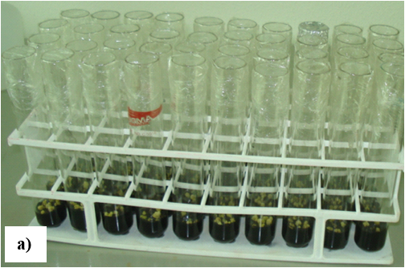
31. 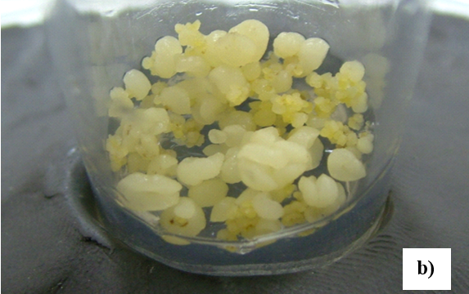
32. **Figura S1. (a)** *In vitro* culture of *O. catharinensis* embryos; **(b)** Somatic embryos in the globular stage.



1. **Figure S2.** Chromatographic profile by HPLC (detection at 280 nm) of CHCl3 extract from somatic embryos of *O. catharinensis*.



1. **Figure S3.** 13C NMR spectrum (DMSO, 200 MHz) of [8-13C]-ferulic acid.
2. 
3. **Figure S4.** 13C NMR spectrum (CDCl3, 200 MHz) of methyl [8-13C]-ferulate.



1. **Figure S5.** 13C NMR (CDCl3, 200 MHz) spectrum of [8-13C]-coniferyl alcohol.



1. **Figure S6.** 13C NMR (CDCl3, 50 MHz) spectrum of [8-13C]-glycoferulic acid.



1. **Figure S7.** 13C NMR spectrum (D2O, 50 MHz) [8-13C]-glycoferulic acid.



1. **Figure S8.** 13C NMR (CDCl3, 50 MHz) spectrum of methyl [8-13C]-ferulate protected with TBS.
2. 
3. **Figure S9.** 13C NMR (CDCl3, 50 MHz) spectrum of [8-13C]-coniferyl alcohol protected with TBS.
4. 
5. **Figure S10.** 13C NMR (CDCl3, 50 MHz) spectrum of [8-13C]-coniferyl acetate protected with TBS.



1. **Figure S11.** 13C NMR spectrum (CDCl3, 50 MHz) of [8-13C]-coniferyl acetate.

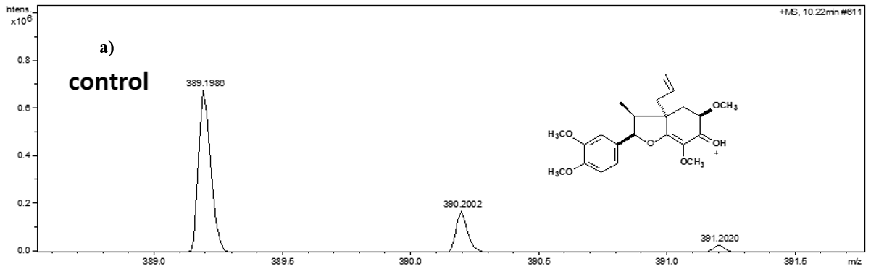

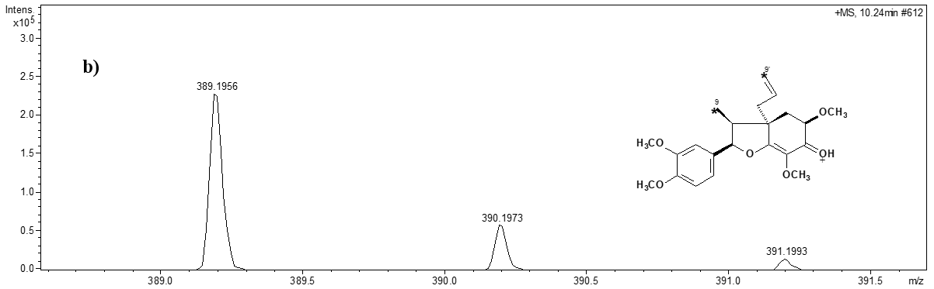

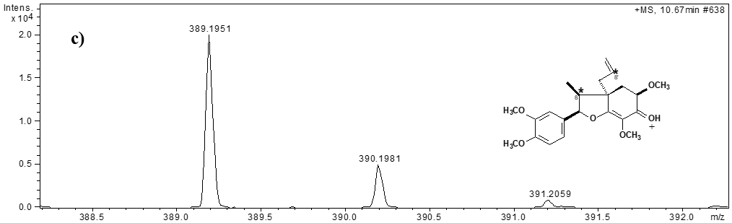

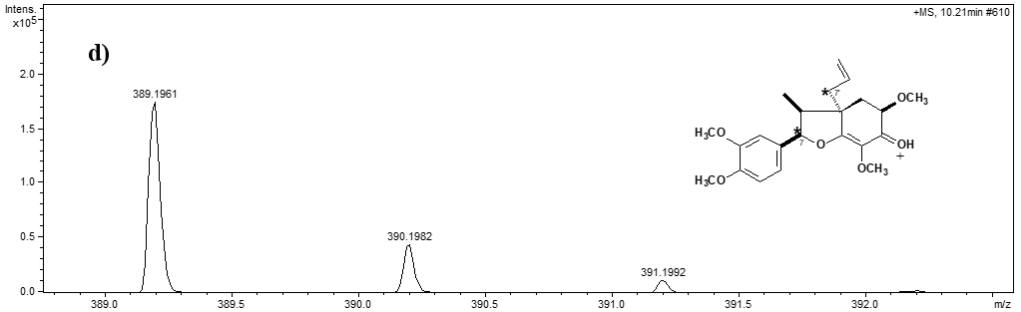

1. **Figure S12.** Mass spectra (ESI) of 13C incorporation in 5’-methoxy porosin. **(a)** Control; **(b)–(d)** 5’-methoxy-porosin incorporated with *L*-[1-13C], *L*-[2-13C] and *L*-[3-13C]-phenylalanine, respectively.
2. 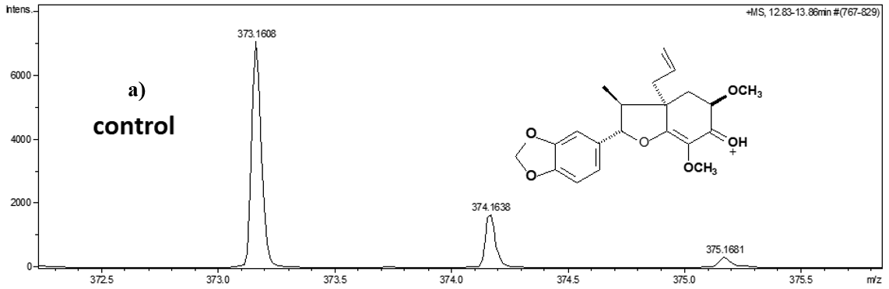
3. 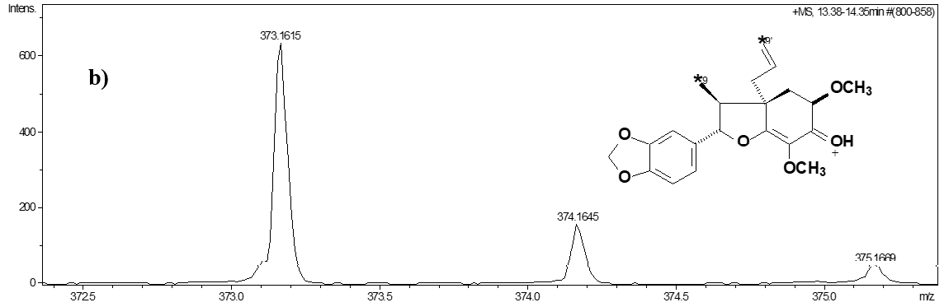

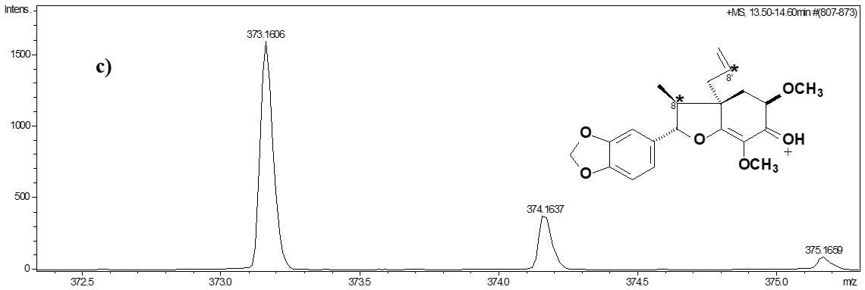

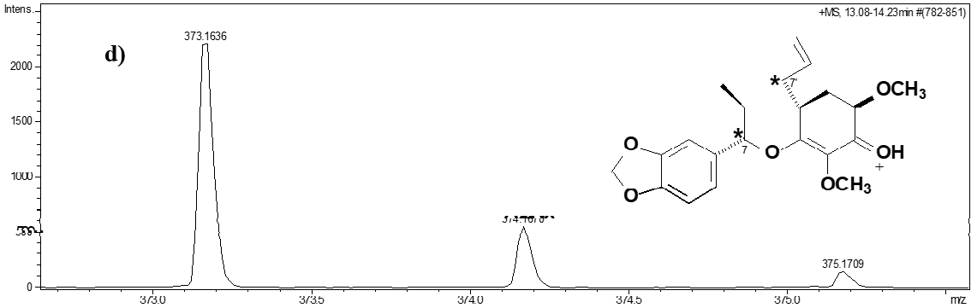

1. **Figure S13.** Mass spectra (ESI) of 13C incorporation in armenin B. **(a)** Control; **(b)–(d)** armenine B incorporated with *L*-[1-13C], *L*-[2-13C] and *L*-[3-13C]-phenylalanine, respectively. *Positions enriched with 13C.

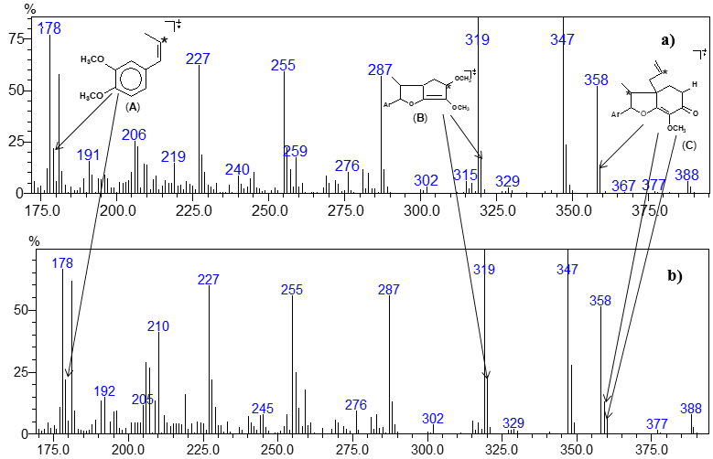

1. **Figure S14.** Mass spectra (EI) of 5'-methoxy-porosin with natural abundance (A); (B) Incorporation of [8-13C]-coniferyl acetate; **(a)** Expansion of (A); **(b)** Expansion of (B).

**References**

[Bastos, E. L.; Ciscato, L. F. M. L.; Baader, W. J., Microwave-assisted protection of phenols as tert-butyldimethylsilyl (TBDMS) ethers under solvent-free conditions.](https://doi.org/10.1081/SCC-200057992) *[Synth. Commun.](https://doi.org/10.1081/SCC-200057992)* **[2005,](https://doi.org/10.1081/SCC-200057992)***[35](https://doi.org/10.1081/SCC-200057992)* [(11), 1501–1509. https://doi.org/10.1081/SCC-200057992](https://doi.org/10.1081/SCC-200057992)

[Boschi, D.; Tron, G. C.; Lazzarato, L.; Chegaev, K.; Cena, C.; Di Stilo, A.; Giorgis, M.; Bertinaria, M.; Fruttero, R.; Gasco, A. NO-donor phenols: a new class of products endowed with antioxidant and vasodilator properties.](https://doi.org/10.1021/jm0510530) *[J. Med. Chem.](https://doi.org/10.1021/jm0510530)* **[2006,](https://doi.org/10.1021/jm0510530)***[49](https://doi.org/10.1021/jm0510530)* [(10), 2886–2897. https://doi.org/10.1021/jm0510530](https://doi.org/10.1021/jm0510530)

[Katayama, T.; Davin, L. B.; Lewis, N. G. An extraordinary accumulation of (–)-pinoresinol in cell-free extracts of Forsythia intermedia: evidence for enantiospecific reduction of (+)-pinoresinol.](https://doi.org/10.1016/S0031-9422(00)97545-9) *[Phytochemistry.](https://doi.org/10.1016/S0031-9422(00)97545-9)* **[1992](https://doi.org/10.1016/S0031-9422(00)97545-9)**[,](https://doi.org/10.1016/S0031-9422(00)97545-9) *[31](https://doi.org/10.1016/S0031-9422(00)97545-9)* [(11), 3875–3881. https://doi.org/10.1016/S0031-9422(00)97545-9](https://doi.org/10.1016/S0031-9422(00)97545-9)

[Koeduka, T.; Fridman, E.; Gang, D. R.; Vassao, D. G.; Jackson, B. L.; Kish, C. M.; Orlova, I.; Spassova, S. M.; Lewis, N. G.; Noel, J. P.; Baiga, T. J.; Dudareva, N.; Pichersky, E. Eugenol and isoeugenol, characteristic aromatic constituents of spices, are biosynthesized via reduction of a coniferyl alcohol ester.](https://doi.org/10.1073/pnas.0603732103) *[Proc. Natl. Acad. Sci.](https://doi.org/10.1073/pnas.0603732103)* **[2006](https://doi.org/10.1073/pnas.0603732103)**[,](https://doi.org/10.1073/pnas.0603732103) *[103](https://doi.org/10.1073/pnas.0603732103)* [(26), 10128–10133. https://doi.org/10.1073/pnas.0603732103](https://doi.org/10.1073/pnas.0603732103)

[Mohri, K.; Watanabe, Y.; Yoshida, Y.; Satoh, M.; Isobe, K.; Sugimoto, N.; Tsuda, Y., Synthesis of glycosylcurcuminoids.](https://doi.org/10.1248/cpb.51.1268) *[Chem. Pharm. Bull.](https://doi.org/10.1248/cpb.51.1268)* **[2003](https://doi.org/10.1248/cpb.51.1268)**[,](https://doi.org/10.1248/cpb.51.1268) *[51](https://doi.org/10.1248/cpb.51.1268)* [(11), 1268–1272. https://doi.org/10.1248/cpb.51.1268](https://doi.org/10.1248/cpb.51.1268)

[Schiaffo, C. E.; Dussault, P. H. Ozonolysis in Solvent/Water Mixtures: Direct Conversion of Alkenes to Aldehydes and Ketones.](https://doi.org/10.1021/jo800323x) *[J. Organic Chemistry](https://doi.org/10.1021/jo800323x)* **[2008,](https://doi.org/10.1021/jo800323x)***[73](https://doi.org/10.1021/jo800323x)* [(12), 4688–4690. https://doi.org/10.1021/jo800323x](https://doi.org/10.1021/jo800323x)

[Stöckigt, J.; Klischies, M. Biosynthesis of lignans: Part I. Biosynthesis of arctiin (3) and phillyrin (5).](https://doi.org/10.1515/hfsg.1977.31.2.41) *[Holzforschung](https://doi.org/10.1515/hfsg.1977.31.2.41)***[1977](https://doi.org/10.1515/hfsg.1977.31.2.41)**[,](https://doi.org/10.1515/hfsg.1977.31.2.41) *[31](https://doi.org/10.1515/hfsg.1977.31.2.41)* [(2), 41–44. https://doi.org/10.1515/hfsg.1977.31.2.41](https://doi.org/10.1515/hfsg.1977.31.2.41)