Supplementary Material

Chemical profiles and antimicrobial activities of plants utilized in Brazilian traditional medicine

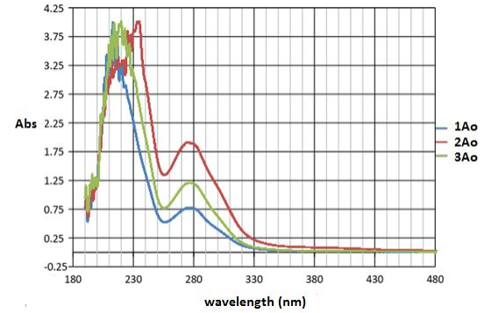
Figure 1. UV-Visible absorption spectral of ethanolic extracts of Anacardium occidentalis samples.

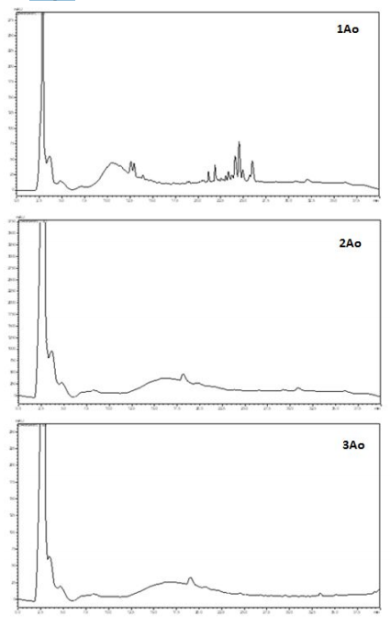

Figure 2. Chemical profiles obtained by HPLC of ethanolic extracts of Anacardium
occidentalis samples.

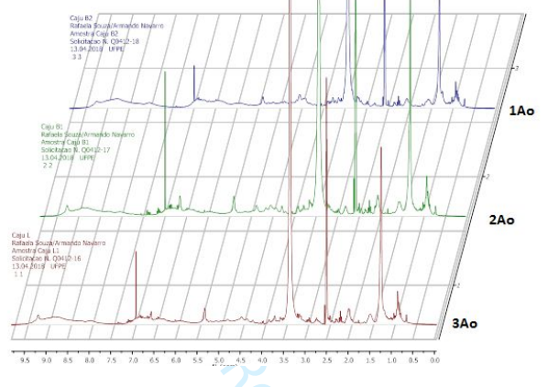
Figure 3. 1H NMR spectral (300 MHz, DMSO) of ethanolic extracts of Anacardium
occidentalis samples.

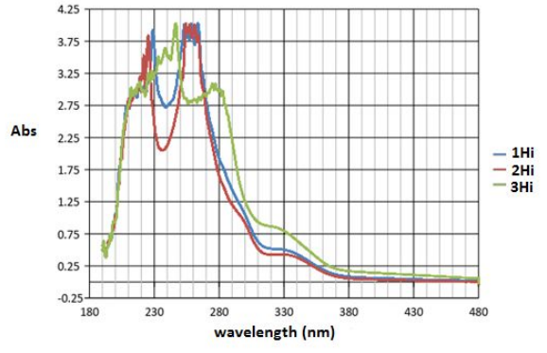
Figure 4. UV-Visible absorption spectral of ethanolic extracts of Handroanthus impetiginosus samples.

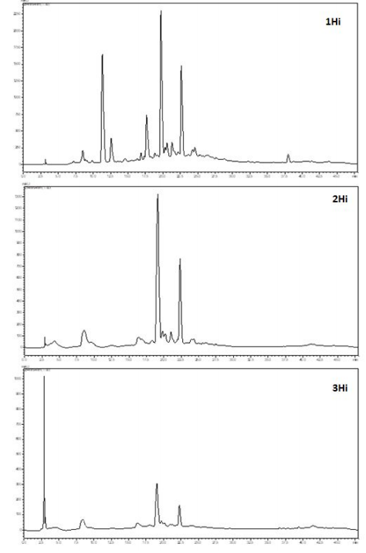
Figure 5. Chemical profiles obtained by HPLC of ethanolic extracts of Handroanthus impetiginosus samples.

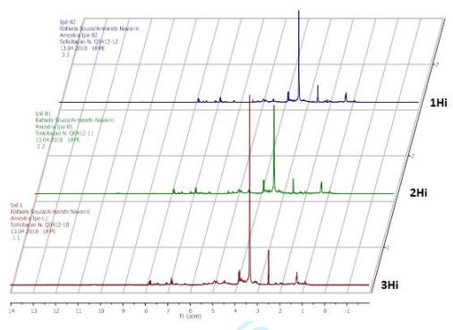
Figure 6. 1H NMR spectral (300 MHz, DMSO) of ethanolic extracts of Handroanthus impetiginosus samples.

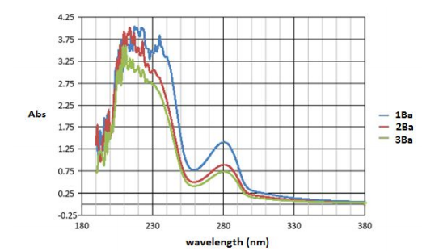
Figure 7. UV-Visible absorption spectral of ethanolic extracts of Bumelia sartorum samples.

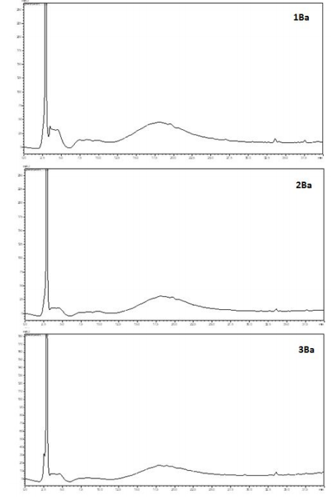
Figure 8. Chemical profiles obtained by HPLC of ethanolic extracts of Bumelia sartorum samples.

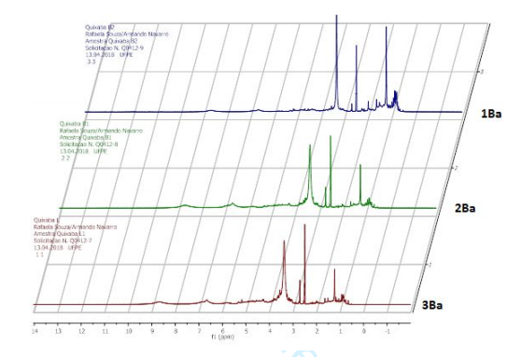
Figure 9. 1H NMR spectral (300 MHz, DMSO) of ethanolic extracts of Bumelia sartorum samples.

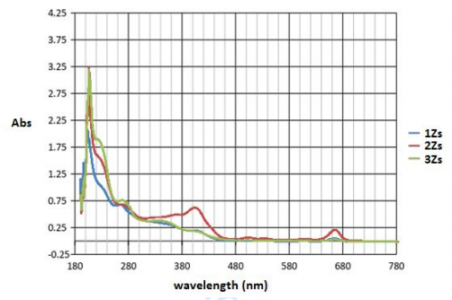
Figure 10. UV-Visible absorption spectral of ethanolic extracts of Zornia sp samples.

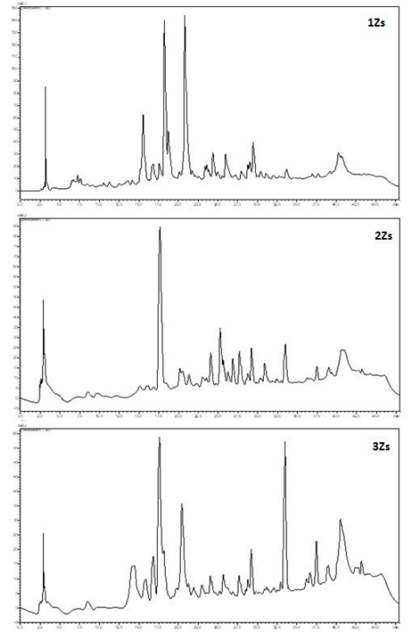
Figure 11. Chemical profiles obtained by HPLC of ethanolic extracts of Zornia sp samples.

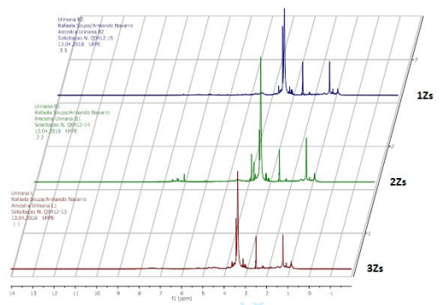
Figure 12. 1H NMR spectral (300 MHz, DMSO) of ethanolic extracts of Zornia sp samples.

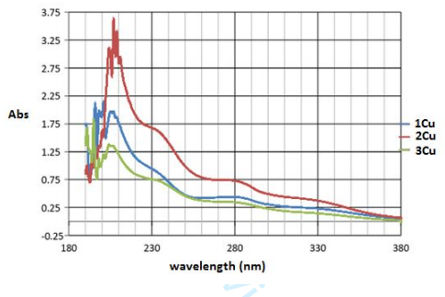
Figure 13. UV-Visible absorption spectral of ethanolic extracts of Cnidosculus urens samples.

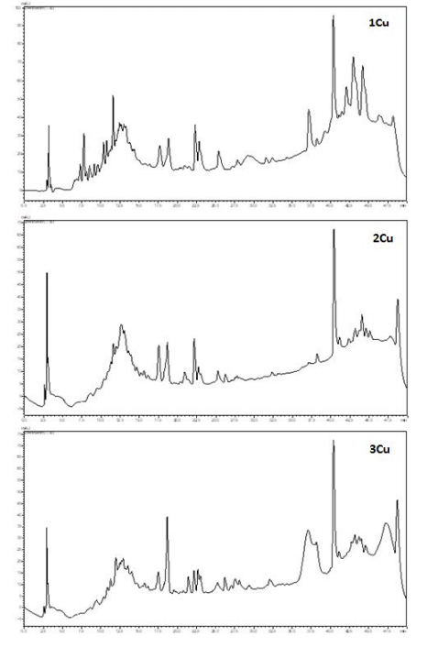
Figure 14. Chemical profiles obtained by HPLC of ethanolic extracts of Cnidosculus urens samples.

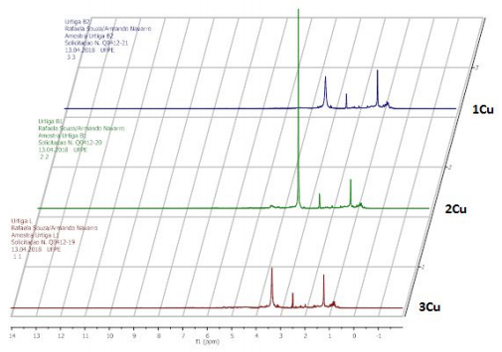
Figure 15. 1H NMR spectral (300 MHz, DMSO) of ethanolic extracts of Cnidosculus urens samples.

