  - APPENDIX 3b:

Comparison of chemistry students in solving algorithmic, conceptual and open-ended problems

ABSTRACT: This study has been conducted to analyse the level of students’ achievements in solving chemistry problems. The question was developed in the form of algorithm, conceptual and open-ended problems solving. The lack of previous research in evaluating students' effectiveness in solving various types of problems highlights the need to understand how well students grasp fundamental concepts in chemistry. The aim of research is to identify and compare the level of students’ achievements on all the three types of problems (algorithmic, conceptual and open-ended). This study implements quantitative design using a paper-and-pencil test. A set of questions consist of three different topic (mole concept, acid base and polymer) was created as an instrument and purposive sampling was conducted. The instrument was answered by 42 high school chemistry students from a private school in Johor Bahru. Descriptive statistics such as frequency and percentage were used to summarize the achievement level of students to solve the three types of problem solving. Data were analyzed using SPSS 27.0. Based on the findings, open-ended problems show a 78.6% low level of achievement. Compared to algorithmic problems, 9.52% and conceptual scoring which is 16.7% of low level of achievement. By referring to the percentage, this concludes that among the three types of problem solving, open-ended problem is difficult to be mastered by the students. Moreover, the results prove the weakness of students to understand the concepts underlying open-ended questions. More effort needs to be made to boost students' problem-solving skills in chemistry, such as cultivate a culture of problem-solving in the classroom.

Keywords
- problem solving; 2. algorithmic; 3. conceptual; 4. open-ended; 5. chemistry; 6. Students’ achievement

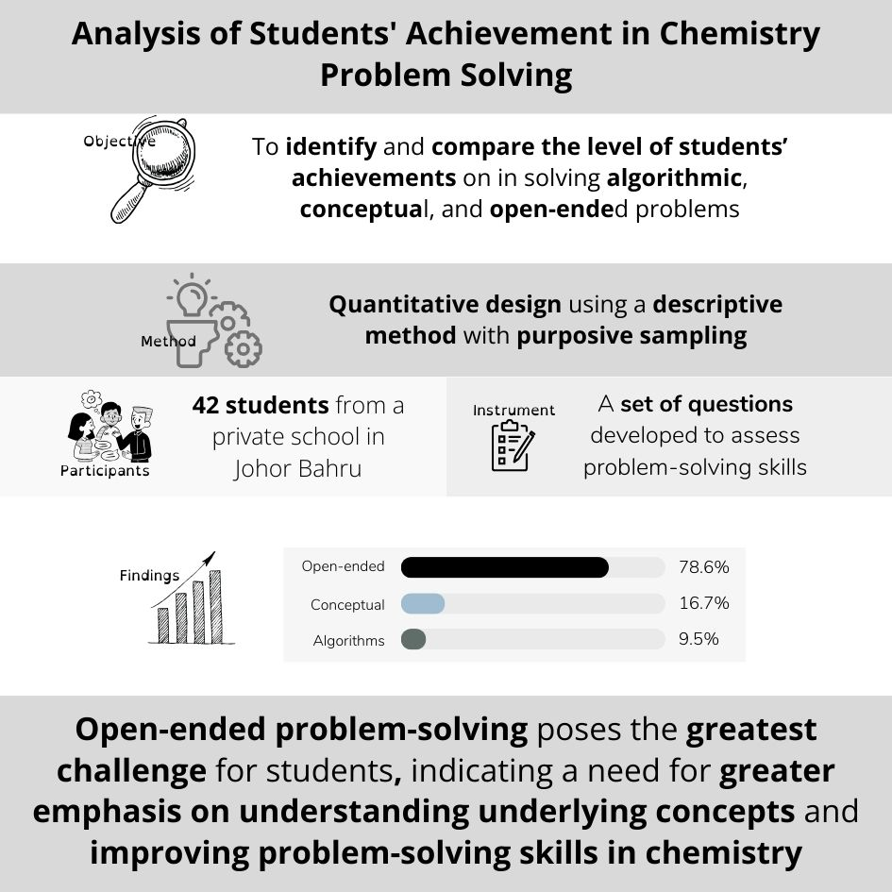

- Introduction

Chemistry can be defined as the branch of science that relates to the properties of composition, element and compound structure, how they change and the release or absorption of energy when they change. Chemistry is an important subject as it discusses the composition and structure of things surrounding us (Sausan et al., 2021). It also explains the natural phenomena that occur in our daily life, and helps us to solve our problems scientifically. However, it is an unpopular subject among students. This subject requires the students to give an effort in comprehending the concepts. Compared to language and other subjects, chemistry is more abstract because it comprises macroscopic, microscopic, and symbolic domains that describe chemical behaviors in different ways. Majority of secondary students think that chemistry is a difficult subject (Sausan et al., 2021). The difficulties of learning chemistry make students have a negative perception towards chemistry. Studies show that they are less interested and less motivated in learning chemistry concepts (Sausan et al., 2021).
Based on results released by the Organisation for Economic Cooperation and Development (OECD), Malaysia scored 440 in Mathematics, 415 in Reading and 438 in Scientific literacy in Programme for International Student Assessment (PISA) 2018 (Malaysia of Education, 2018). It remained below the average score achieved by the Organization for Economic Co-operation and Development (OECD). The current situation poses a significant challenge that requires urgent attention and immediate action to overcome because the development of our country depends on the development of science and technology (Nsanzimana et al.,2021). The advancement of science and technology depends on the professional and well-skilled people who excel in science understanding and are able to apply the scientific knowledge in our daily life (Nsanzimana et al.,2021).
Students have not been given the idea of the method to solve chemistry problems effectively. Students are not adequately equipped with the cognitive and affective skills necessary to apply their learning effectively in both academic and real-life situations (Johari et al., 2014; Aydin-Gunbatar & Kalender, 2019). To foster a greater interest in acquiring knowledge of chemistry among students, measures need to be taken. Recent studies were conducted emphasize the importance of integrating different problem-solving approaches. These approaches include solving the problem of algorithmic, conceptual, and open-ended, which each play unique roles in enhancing students' understanding and engagement. (Johari et al., 2014; Aydin-Gunbatar & Kalender, 2019). However, there is limited evidence on how integrating these approaches could lead to improved outcomes, particularly in chemistry education.
Algorithmic problem-solving only focuses on step-by-step procedures and formulas. It is often criticized for promoting rote learning without encouraging deep understanding even it helps students solve structured problems such as stoichiometric problem (Rosa, & Lewis, 2019). Conceptual problem-solving approaches emphasize understanding the underlying scientific principles rather than just applying formulas. This method helps students grasp fundamental concepts in chemistry, including acid and base, atomic structure and chemical bonding (Valdez, & Bungihan, 2019). Last problem is open-ended where these problems have no single correct answer and it required students to evaluate various solutions. It can encourage creativity, higher-order thinking, and the application of knowledge in real-world contexts. Plus, it also demonstrates the effectiveness of open-ended problem-solving in fostering students' abilities to tackle complex, real-life chemistry scenarios. (Heliawati, Afakillah, & Pursitasari, 2021).
Therefore, this study aims to fill these gaps by identifying the achievement level of chemistry high school students in three types of problem solving (algorithmic, conceptual and open-ended). Ultimately, this study aspires to contribute to the advancement of chemistry education. Plus, it able to provide insights that can help improve student performance in international assessments and align educational outcomes.

  - Problem Solving

A problem can be described as a situation that arises when there is a disparity between the current position and desired goal. Problem-solving plays a crucial role in all scientific disciplines and solving problems can reveal fundamental concepts underlying those disciplines (Frey, Brame, Fink, & Lemons, 2022). Problem solving can be defined as the action taken when there is no solution to do. Through problem-solving, students can develop a deep understanding of chemical concepts and connect them to practical applications. These skills are also relevant in career preparation, enabling students to design experiments, analyse data, and overcome challenges. With these skills, students become proficient problem-solvers in the field of chemistry and science. However, problem-solving skills in chemistry have been identified as important skills that are lacking among students in current education (Chiu et al., 2022). Students often encounter difficulties when solving problems as it involves critical thinking and in-depth analysis (Stroumpouli & Tsaparlis, 2022).
In the context of chemistry, problem-solving is critical because it allows students to apply theoretical knowledge for practical situations. An example, in stoichiometry problem, students need to determine the amounts of reactants and products in a chemical reaction. This requires both algorithmic problem-solving (applying formulas and procedures) and conceptual understanding which required grasping the law of mass conservation. As for open-ended problem solving, such as chemical equilibrium topic, students must analyse reaction rates and the dynamic nature of reversible reactions. Here, open-ended problem-solving becomes important as students explore different conditions (such as temperature or concentration) that can affect the outcome of a reaction. This approach fosters deeper understanding and prepares students to handle real-world applications. The use of problem-solving in these areas supports students' ability to think critically, and apply their chemistry knowledge to complex open-ended problems. It can bridge the gap between theoretical learning and practical application. This approach not only enhances learning outcomes but also prepares students for future careers in STEM fields.
In this research, different topics are chosen for solving algorithmic, conceptual, and open-ended problems in chemistry to assess a range of cognitive skills and knowledge. Algorithmic problems focus on students' ability to apply formulas and perform calculations, emphasizing procedural skills in areas like stoichiometry or chemical equations. Conceptual problems, on the other hand, assess understanding of core principles and theories, such as atomic structure or thermodynamics, requiring deeper comprehension of how and why processes occur. Open-ended problems involve applying chemistry knowledge to complex, real-world scenarios, fostering critical thinking, creativity, and problem-solving. By using a variety of topics, teachers can evaluate both the practical and theoretical understanding of students across different cognitive domains.

1.2 Algorithmic Problem
Algorithmic type of problem solving can be defined as a step-by-step process is needed to resolve equations or numerical calculation problems. The correct formula or equations are needed to calculate this type of problem. According to Reid and Yang (2002) in Sangguroa & Surifa (2019), an algorithmic problem is a problem in which required data are given, the solution method is known, and the objective is clearly defined. This type of problem does not assess the student's problem-solving skills, but rather emphasizes their capacity to consistently apply acquired knowledge. According to Frank et al. (1987), algorithmic problems serve as helpful shortcuts for practicing exercises, but one disadvantage is that they can impede understanding when students encounter real-world problems. However, according to Nurrenbern and Pickering (1987), algorithmic problems tend to discourage the development of conceptual understanding among students. If the initial response of a student is to simply select which algorithms to utilize, it indicates that the student has not truly solved the problem at hand (Frank et al., 1987). To minimize reliance on rote learning, it is important for students to possess a solid conceptual understanding of chemistry.
A few topics in chemistry that are said to be difficult to learn including chemical equation, stoichiometry, mole concept, and acid base (Rosa, Corrales, Nguyen, & Atkinson, 2022). A study from Shadreck and Enunuwe (2018) highlighted that 66% of students under the control group showed difficulty in understanding the mole concept in a stoichiometry pretest. Even after the post-test, they proved that the number only reduced to 48% of students. For example, students need to calculate the number of moles for hydrogen gas produced when 5 moles of zinc react with excess hydrochloric acid (HCl).

1.3 Conceptual Problem

Conceptual questions typically present students with chemical scenarios that they are unfamiliar with. This question necessitates that students justify their choices, predict future occurrences, explain processes, establish connections between various topics, recognize questions presented in a novel manner, and extract valuable information from multiple sources or broad scopes. Students are required to synthesize their answers and evaluate the problem in order to determine an appropriate mathematical tool for solving it.
According to Cracolice et al. (2008), a conceptual problem necessitates that students focus on enhancing their understanding of the underlying concept rather than relying on memorized procedures. A strong conceptual understanding of the relevant topics is essential for students to successfully solve conceptual questions (Haláková and Proksa, 2007; Hurrel, 2021).

One of the problems that students find difficult to understand in chemistry is acid and base concepts. A study by Yaman et al. (2019) showed that the main problem faced by students is the understanding of acid and base concepts. They tend to only associate acids with H⁺ ions and bases with OH⁻ ions, without a deep understanding of the characteristics and reactions of acids and bases. Another study by Tóthová et al. (2021) and Tóthová & Rusek (2021) found that students lack skills in solving conceptual chemistry problems.
Conceptual problem solving is essential for students as it assists students in attaining a more comprehensive and in-depth learning experience. It also helps to strengthen their comprehension and proficiency in applying acquired knowledge to novel situations (Rillero, 2016). Students’ critical thinking abilities would be enhanced via enhanced conceptual problem-solving ability. It also fosters students’ enthusiasm for science and the pursuit of knowledge (Rillero, 2016). This type of problem solving evaluates students’ understanding of a subject matter, rather than solely assessing their knowledge and problem-solving abilities. It also offers a means to identify and address students' misconceptions through diagnostic assessment.
  - Open-Ended Problem

An open-ended problem is a problem that does not have a singular correct answer, instead has the possibility of multiple correct answers (Fitriana et al., 2018). Critical thinking skill, creativity, and problem-solving skill are needed in order to solve this type of problems (Fitriana et al., 2018). According to Authority, (2010) and Aziza (2021), open-ended questions in chemistry are designed to evaluate a student's understanding of fundamental concepts rather than their ability to memorize specific facts. This approach ensures that students are not impeded from answering the questions solely due to a lack of recall, as there are always multiple alternative paths to arrive at the ultimate solution. It is important to have open-ended problem-solving skills (Bayarcal & Tan, 2023). This is because creative and adaptable solutions are required to solve many challenging real-world problems in an effective and practical way. One will come out with new ideas and innovations that can improve the world once mastering open-ended problem-solving skills (Bayarcal & Tan, 2023). Furthermore, collaboration and teamwork are required to solve open-ended problems which are indirectly able to learn others’ perspectives and experiences.
It is very crucial for students to acquire problem solving skills for development of conceptual understanding and ability to solve real life problems with scientific skills among students. Specifically, this research is to examine students’ level of ability in solving these types of problems which include algorithmic problems, conceptual problems and open-ended problems. According to the Curriculum Development Department, In Malaysia education, the KSSM curriculum emphasizes active learning and critical thinking. Students are taught to analyze problems, collect data, identify the causes of problems, and formulate solutions in the subject of Chemistry. Thus, the KSSM curriculum helps develop students to solve problems related to chemistry concepts. The change in curriculum from KBSM to KSSM may potentially affect students' performance in solving real-life problems. Therefore, a new study needs to be conducted to examine how the KSSM curriculum influences students to solve the problems. In response to these challenges, a study has proposed to examine the students' level of achievement in solving various types of problems in chemistry (algorithmic, conceptual, and open-ended). Thus, this study aims:

- To identify students’ level of achievement in algorithmic problems
- To identify students’ level of achievement in conceptual problems
- To identify students’ level of achievement in open-ended problem
- To compare students’ level of achievement in algorithmic problems, conceptual problems and open-ended problems

2. Methodology

The study focuses on identifying and comparing the chemistry students’ level of achievement in solving algorithmic, conceptual, and open-ended problems. This methodology section covers aspects such as research design, population and sampling, data collection instruments, and data analysis techniques.

2.1 Research Design

A quantitative study utilizing a descriptive research design was conducted to address the research objectives. This approach involved systematically collecting numerical data to describe and assess key characteristics related to the research topic. The data collection process was executed using a paper-and-pencil test, where participants were asked to complete a series of standardized questions designed to measure their knowledge, skills, or understanding of the subject matter. This method of data collection allowed for straightforward administration and reliable quantification of results, ensuring that the data could be analysed effectively to meet the study's goals.

2.2 Population and Sample

For this study, purposive sampling was employed by choosing 42 high school chemistry students from a private school in Johor Bahru. This school was chosen due to its diverse student population, which reflects a range of academic proficiencies and backgrounds, making it an ideal setting to examine different problem-solving abilities in chemistry. The purposive sampling method was selected to ensure that the participants included students with varying levels of proficiency in chemistry, from high achievers to those who struggle with the subject. According to Etikan et al. (2016), this diversity is crucial for a comprehensive comparison across different cognitive domains related to algorithmic, conceptual, and open-ended problem-solving.
The sample size of 42 chemistry students was determined based on the feasibility of conducting in-depth analyses while achieving statistically meaningful comparisons. All the students selected for this study were 17 years old and had been exposed to chemistry from the same year, ensuring they had an equal foundation in the subject. This uniform exposure to chemistry provides a consistent basis for assessing their problem-solving abilities, minimizing any confounding variables related to differing levels of prior knowledge or experience. The sample was evenly distributed across gender, ensuring that the study's findings are not biased toward a particular demographic group.

2.3 Instruments

To collect the necessary data, a series of tests were administered as instruments to the students. These tests comprised three types of problem-solving questions specifically designed to assess students' abilities in solving algorithmic, conceptual, and open-ended problems. Each test was carefully crafted to ensure clarity and relevance to the chemistry curriculum, allowing students to demonstrate their understanding of key concepts and problem-solving strategies.

2.3.1 Algorithmic Problems

The algorithmic problems focused on numerical calculations, the application of formulas, requiring students to follow step-by-step procedures. Each of these questions requires students to follow a defined set of steps, which is a hallmark of algorithmic problem-solving. Table 1 below presents a set of algorithmic questions used in the study to evaluate students' problem-solving abilities in chemistry. Each question is designed to test the application of specific formulas and procedures, reflecting the systematic and procedural nature of algorithmic problem-solving. Table 1 also includes explanations for how each question relates to the development of these skills, emphasizing the role of algorithmic learning in reinforcing students' understanding of fundamental chemical concepts.

Table 1. Algorithmic questions in chemistry: assessment of problem-solving skills

Questions | Explanation
1.A gas jar contains 300 cm³ of ammonia gas at room condition. Calculate:  a) The number of  mol of ammonia gas. | This question typically uses the formula n=$\frac{V}{M}$, where n is the number of moles, V is the volume of gas, and M is the molar volume. Students must identify the relevant values and apply the formula to find the solution. This type of calculation emphasizes the procedural aspect of problem-solving.
b) The mass of  ammonia gas. | This question relates to question (a). After students get the number of moles, students need to calculate the mass of ammonia using formula, Mass (g) = number of mole x Molar Mass.
c) The number of  atoms in ammonia gas. | This question involves Avogadro's Constant (6.02×10²³) to find the total number of atoms. Students need to calculate the number of atoms using formula. (number of particles = number of mole x Avogadro's Constant x number of ammonia atom in one molecule of ammonia gas).
d) Nitrogen gas can react with hydrogen gas to produce ammonia gas under certain conditions.  I)Write the balanced chemical equation for the reaction.  II)Calculate the volume of hydrogen gas needed in this reaction if 300 cm³ of nitrogen gas used measured under the same reaction condition. | I) This task assesses students' understanding of the stoichiometry relationships in chemical reactions, requiring them to recognize the reactants and products involved and ensure that mass is conserved in the equation. This is a critical skill in chemistry that connects algorithmic problem-solving with conceptual understanding.
 | II)This question typically uses stoichiometry to determine the volume of hydrogen gas required to produce a specific amount of ammonia. It emphasizes the application of theoretical knowledge to practical situations.

Algorithmic questions in chemistry are essential because they require students to follow established procedures, reinforcing their procedural knowledge and enhancing their problem-solving abilities. By applying systematic approaches to solve specific types of problems, students learn to navigate the complexities of chemical calculations with confidence (Vo, Sarkar, White & Yuriev, 2022). These questions often involve mathematical skills, allowing students to practice and strengthen their ability to perform calculations relevant to chemical concepts. Furthermore, mastering algorithmic problem-solving fosters confidence, as students become adept at tackling quantitative problems, which serves as a foundation for developing higher-order thinking skills. Additionally, these questions are valuable for educators, as they provide insight into students' understanding of fundamental concepts and their capacity to apply that knowledge in practical scenarios. Overall, algorithmic questions play a crucial role in chemistry education by enabling students to effectively solve quantitative problems and prepare for more complex conceptual challenges (Tsaparlis, 2021: Rau, Zahn, Misback, Herder, & Burstyn, 2021).

2.3.2 Conceptual Problems

The conceptual problems presented scenarios that necessitated a deeper understanding of chemical principles, encouraging students to connect different topics and apply their knowledge creatively (Rahmawati, Hartanto, Falani, & Iriyadi, 2022). Each questions targets key aspects of chemical theory, encouraging students to engage in deeper thinking rather than simply recalling memorized facts. Table 2 outlines a series of conceptual questions used to evaluate students' comprehension of fundamental chemical concepts related to acids. Each question is crafted to challenge students to think critically and apply their knowledge in new contexts, moving beyond simple recall to engage in deeper analytical thinking. Table 2 also provides explanations for how each question relates to conceptual problem-solving, emphasizing the integration of knowledge and the application of scientific principles.

Table 2. Conceptual questions in chemistry: assessment of understanding and application of acid-related concepts

Questions | Explanation
I) What is meant by acid? | It prompts students to articulate their understanding of acids in terms of their properties and characteristics, such as their ability to produce H⁺ ions in aqueous solutions. This requires students to synthesize knowledge from different areas of chemistry.
II) State the ion that enables an acid to show its acidic properties. | This question encourages students to connect the concept of acidity with the ionization process which produce hydrogen ion that can show the acidic properties.
III)Suggest the name of acid P and acid Q. | It requires students to apply their knowledge of chemical nomenclature. This not only tests their ability to identify specific acids but also assesses their familiarity with common acids and their formulas.
IV) Acid P and acid R have the same concentration. It was found that the pH value of acid P is lower than acid R. Explain why the pH value of both acids are different. | It challenges them to apply their understanding of concepts such as dissociation and strength of acids. This question emphasizes the importance of understanding that pH is influenced by factors beyond concentration, such as the acid's inherent strength and degree of ionization.

These questions exemplify conceptual problem-solving in chemistry because they require students to integrate their knowledge and apply it to new scenarios. They encourage critical thinking and analysis, as students must justify their answers based on scientific principles rather than relying solely on rote memorization. By engaging with these conceptual questions, students deepen their comprehension of acid-related concepts, which is essential for their overall success in chemistry (Kilpatrick, 2020).
2.3.3 Open-ended Problems

The open-ended problems require students to explore multiple pathways to arrive at solutions, fostering critical thinking and creativity Shanta, & Wells, 2022). The open-ended questions presented here are designed to encourage students to explore complex concepts related to the use of polyvinyl chloride (PVC) in water pipe manufacturing and its environmental implications. Table 3 presents a set of open-ended questions designed to assess students' ability to analyse and articulate complex issues related to the use of polyvinyl chloride (PVC) in water pipe manufacturing and its environmental impact. Each question encourages students to explore practical applications, environmental considerations, and ethical implications, fostering critical thinking, creativity, and problem-solving skills. Table 3 also includes explanations for how these questions relate to open-ended problem-solving, highlighting the importance of addressing multifaceted problems that allow for a variety of valid responses.

Table 3. Open-ended questions in chemistry evaluating critical thinking and application in real-world contexts

Question | Explanation
a) State and explain the importance of using PVC in the manufacture of  water pipes. | It prompts students to consider the practical applications of PVC in real-world scenarios. This question encourages them to think critically about the material's properties, such as durability, resistance to corrosion, and cost-effectiveness, which make it a popular choice in plumbing. Students must synthesize information and articulate their reasoning, demonstrating a deeper understanding of material science and engineering principles.
b) Explain  how PVC can  cause  environmental  pollution.  Suggest  on ways to  solve this  problem. | It challenges students to examine the broader implications of using PVC, including its production, use, and disposal. This question invites students to engage in environmental science and ethics, requiring them to think about sustainability and the consequences of material choices. By asking for solutions, the question fosters creativity and problem-solving skills, as students must propose practical measures to mitigate PVC-related pollution.

These questions exemplify open-ended problem-solving because they do not have a singular correct answer and allow for a range of responses based on students' perspectives and knowledge. They encourage students to analyse complex issues, consider multiple viewpoints, and express their thoughts in a coherent manner. Such questions are essential for developing students' higher-order thinking skills and their ability to apply scientific knowledge to real-world problems, thus enhancing their overall learning experience in chemistry and related fields.
Prior to administration, the items in each problem were validated by two private school chemistry teachers with ten years’ experience each. The tests were pilot-tested with a small group of students to ensure that the questions were appropriate in terms of difficulty and clarity. The tests were designed to be completed within 40 minutes, allowing students sufficient opportunity to think critically and demonstrate their problem-solving abilities. Students were instructed to complete the tests independently, providing their responses in writing. The data obtained from the tests were meticulously recorded for further analysis, ensuring that each student's performance could be accurately assessed and compared.

2.4 Data Analysis Techniques

Quantitative analysis techniques were applied to analyse the collected data. A set of question consist of three types of question which related to algorithmic, conceptual and open-ended problem was given to the students. The students’ answers were marked and the marks were referred to the answer scheme. The mark achievement for each problem-solving category were then analyse using SPSS 27.0. Descriptive statistics such as frequency and percentage were used to summarize the achievement level of students. The Malaysian Ministry of Education classifies students' chemistry achievement into two categories based on their assessment scores. A score of 40% or higher is regarded as a passing mark, indicating a higher level of achievement in the subject. Conversely, students who score below 40% are considered to have a lower level of achievement in problem solving skill. This research was supported by interviewing five students to provide deeper insights into the students' experiences and perceptions regarding to solve the problem. Table 4 and Table 5 shows the specification table for each item and level of achievement of students.

Table 4. The specification table for each item.
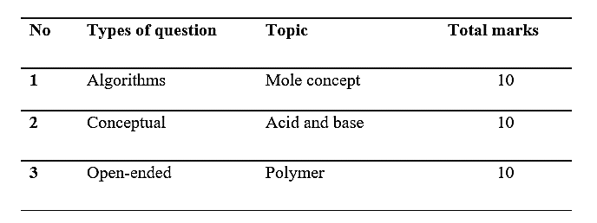

Table 5. Level of achievement
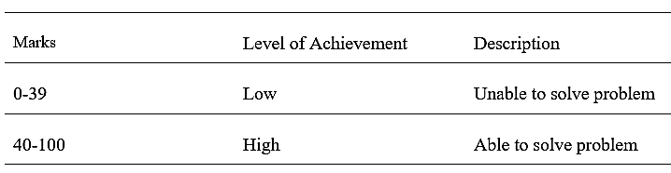
Source: Surif et al., 2014

3. Results and discussion

Table 6 show the frequency and percentage of students’ achievement across three types of questions which are algorithm problems, conceptual problems and open-ended problem. The data illustrates how students performed in each category.

Table 6. The frequency and percentage of students’ achievement on the three types of questions

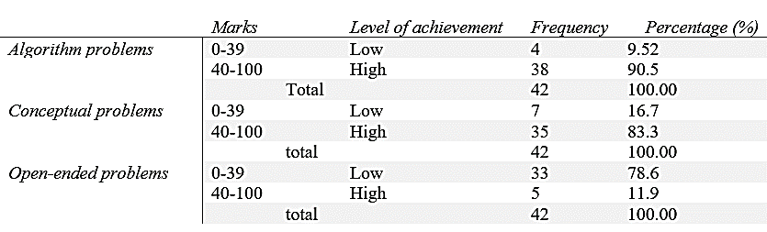

3.1 Students’ level of achievement in algorithmic problems

The findings reveal that the majority of students (90.05%) achieved scores above 40% when solving algorithmic problems, indicating a strong performance in this area. Only a small percentage (9.52%) struggled with these problems, suggesting that most students are proficient in applying the required techniques. This is particularly evident in question number one, which assessed students' understanding of calculations related to the mole concept a fundamental topic in chemistry.
The high level of achievement in algorithmic problems can be attributed to students’ reliance on structured problem-solving techniques and consistent practice. These results are consistent with Olubunmi's (2017) findings, which emphasize that the algorithmic learning method focusing on the three steps of analysis, calculation, and evaluation effectively supports students in mastering mathematical concepts in chemistry. By adhering to these steps, students can systematically approach and solve problems, thereby improving their performance.
Algorithmic learning methods enhance students' problem-solving skills and deepen their understanding of fundamental chemical concepts by promoting critical thinking and application over rote memorization. This approach breaks down complex problems into manageable steps, encouraging students to analyze, evaluate, and synthesize information to find solutions. By emphasizing the relationships between different chemical concepts and processes, algorithmic learning helps students grasp underlying principles and apply their knowledge to new situations, fostering a more comprehensive and adaptable understanding of chemistry (Vo et al., 2022).
This study contributes to existing knowledge by reinforcing the importance of teaching problem-solving techniques in a structured and methodical manner. Furthermore, it suggests that when teachers emphasize the process ensuring students demonstrate in writing how they apply specific techniques students are more likely to internalize these methods, leading to better outcomes in examinations. This insight could inform future pedagogical strategies, particularly in designing curricula that prioritize skill development through algorithmic problem-solving. There are five questions provided based on the information in Figure 1.

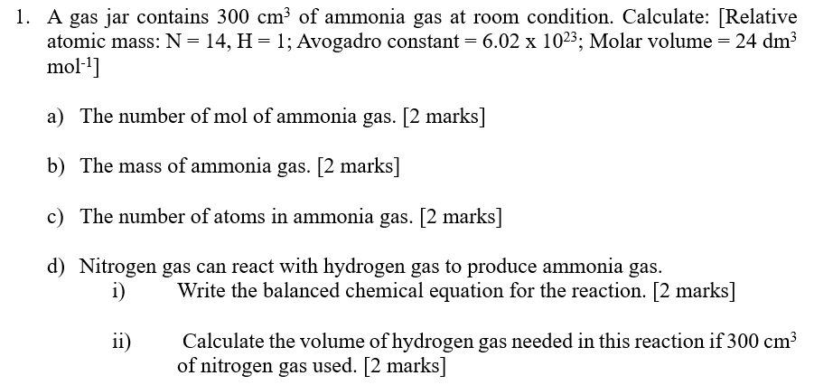
Figure 1. Algorithmic question
All students were able to answer all question number 1(a), 1(b), 1(d)(i) and 1(d)(ii). However, only 14 students can answer question number 1(c) correctly. Most of the students answer the question the same as students sample answer. Students’ misconception about the types of particles because they can’t differentiate between atom, molecule and ions. Plus, this misconception also occurs due to students unable to master the chemical formula (Chophel, 2022). Box 1 show the sample students answers for question 1(c).
Box 1. Sample students’ answer for question 1(c)
Student 1: N(NH₃) = 0.0125 x 6.02x10²³ = 7.525 x 10²¹
Student 2: N = 0.0125 x 6.02 x 10²³ = 7.525 x 10²²

3.2 Students’ level of achievement in conceptual problem.

Secondly, for conceptual problems questions, 83.3% of the students scored a high level of achievement between 40 to 100 marks. Only 16.7% of students scored a low level of achievement (0 to 39%). From these findings, we can conclude that most students are able to solve conceptual problems. For this section, four question was provided four questions based on the information in Figure 2.

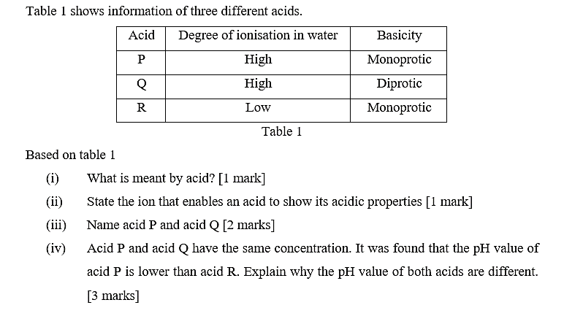
Figure 2. Question for conceptual problem

The main findings of this research reveal several important aspects of students' understanding and misconceptions in chemistry. First, all students were able to successfully answer the first question [2(i)], demonstrating that they are familiar with the basic concept and can elaborate on it correctly. This indicates a strong foundational knowledge in this area, suggesting that the initial teaching strategies or prior exposure to similar questions have been effective. However, the second question [2(ii)] exposed a misconception among students, with one student incorrectly identifying OH⁻ ion instead of H⁺ ion. This mistake likely stems from confusion between different types of ions or a lack of understanding of their charges, highlighting a common issue in chemistry education where students may confuse similar concepts.
For the third question [2(iii)], many students answered correctly but some responded with chemical formulas (e.g., HCl, H₂SO₄) instead of the full names of the acids. This finding suggests that while students can recall chemical formulas, they may struggle with translating this knowledge into the required format, such as using the full chemical names. This points to a gap in instruction regarding the importance of chemical nomenclature. The final question [2(iv)] proved to be the most challenging, with many students unable to correctly address all three required points. This difficulty indicates that while students may grasp individual concepts, they struggle to synthesize these concepts into solving more complex, multi-step problems. This highlights a potential area where additional instructional support or practice might be necessary. Box 2 shows the sample students answer for question [2(iv)].
Box 2. Sample students answer for question 2(iv)

Student1: This is because asid P is strong acid that its degree of ionization in water is higher than acid R, hence its pH value is lower.
Student 2: The Ph of R will be lower as the degree of ionization of R in water is lower, it only partially dissociates in water. Thus, the pH of R will be lower.
Student 3: The pH value of both acids are different because acid P is strong acid which can dissociate fully while acid R is weak acid which can only dissociate partially. Thus, pH value of acid R is higher than acid P.
Student 4: Because acid P is monoprotic acid.

In order to score all the points, students must state that acid P ionizes completely in water to produce high concentration of hydrogen ions. Next, they also need to mention that acid R ionizes partially in water to produce low concentration of hydrogen ions. Then, summarize them in a sentence such as, the higher the concentration of hydrogen ions, the lower the pH value. This question allowed teachers to analyze the students' conceptual understanding and their skills in elaborations. Based on the answers given by the students, there were slight misconceptions detected in explaining the topic.
These findings contribute uniquely to the existing knowledge in chemistry education by providing insights into specific areas where students commonly experience confusion, such as ion identification and the translation of chemical formulas into names. This research underscores the importance of not only testing students' knowledge but also their ability to apply that knowledge in various forms, suggesting a need for more comprehensive instructional strategies that address these issues. Additionally, the study highlights the significance of assessment design in capturing students' true understanding and the necessity of teaching students how to navigate between different representations of chemical knowledge. Overall, this research offers valuable implications for refining educational practices in chemistry, aiming to enhance student understanding and performance.

3.3 Students’ level of achievement in open-ended problem

Based on the result in Table 6 above, regarding the students’ achievement level in solving open-ended problems, only 11.90% of the students achieved high-level marks and can be considered that they are able to answer the open-ended problem. However, 78.60% of them, unable to solve open-ended chemistry problems. Open-ended questions not only give teachers the opportunity to assess their students' level of knowledge, but they also help students strengthen fundamental abilities like observation, analysis, and inference, as well as their creative potential in a number of contexts. Divergent thinking is associated with the open-ended questions that permit multiple correct responses and various solution strategies. Open-ended questions also require students to construct unrestricted responses (Erhan & Bingolbali, 2012).
According to the findings of the study conducted by Siregar, Wahyu, and Sopandi (2020), polymeric, whose applications are frequently seen in day-to-day life is one of the chemicals that has a high volume of the notion of a low level of concept mastery. In addition, the majority of the teachers disregarded the development of the students' comprehension about the polymer concepts. Regarding this research, Figure 3 shows the question of open-ended problems. It consists of two sub questions which are about polyvinyl chloride or vinyl (PVC) and this question primarily assesses mastery of factual knowledge rather than higher-order skills. PVC is a type of polymer in which chlorine contains more than fifty percent of the total component by weight. According to Osama, Basmage and Mohamad (2020) research, it is made through the polymerization of the vinyl chloride monomer. In Malaysia, the current curriculum which is Secondary School Standards-based Curriculum (KSSM), polymer is one of the topics that are included in the syllabus of Form Five Chemistry subject (Sai Mun, 2021).

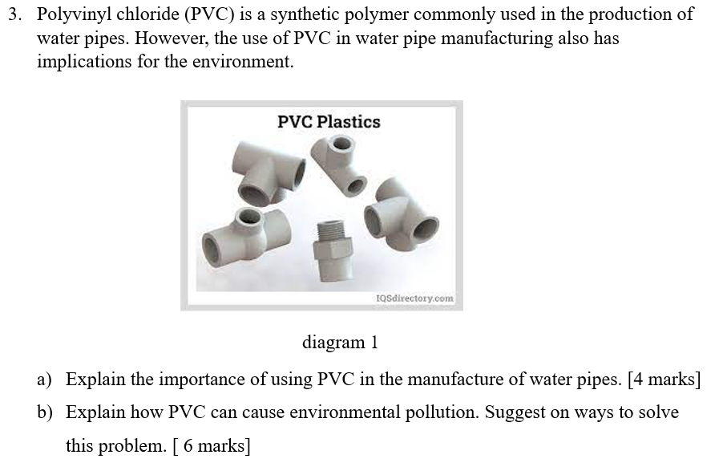
Figure 3. Open-ended question

The main findings of this research indicate significant gaps in students' understanding and ability to articulate key concepts related to the composition and environmental impact of PVC (polyvinyl chloride). When faced with open-ended questions, many students were able to identify key points but failed to elaborate on them in detail. This lack of detailed explanation suggests that while students may have some surface-level understanding, they do not possess the deeper comprehension required to thoroughly explain the concepts. Furthermore, a considerable number of students provided incorrect answers, indicating that they have not yet mastered this essential topic, which is particularly concerning given the relevance of the compounds discussed to their everyday lives.
Specifically, in question 3(a) asked students to state and explain the importance of using PVC in the manufacture of water pipes. The achievement levels of students were varied. This question, contributing 4 marks, revealed that while some students could state the importance of PVC, they struggled to provide a detailed explanation, further highlighting their limited understanding. The Table 7 shows the level of students’ achievement for question 3(a).

Table 7. The level of students’ achievement for question 3(a)

Level of performance | Explanation | Sample student answer.
Excellent  [4 marks] | Demonstrates a comprehensive understanding of the importance of PVC in water pipe manufacturing, providing detailed explanations and mentioning multiple benefits. | S9.PVC is vital for water pipe manufacturing due to its durability, corrosion resistance, cost-effectiveness, lightweight design and smooth flow. PVC pipes are long lasting, resistant to corrosion and can withstand various temperature and pressure. they are lightweight, easy to handle and reduce transportation and labor costs. the smooth inner surface minimizes friction losses and prevents scaling or blockages.
Adequate  [2-3 marks] | Provides some relevant points and explanations, highlighting the durability, corrosion resistance, cost-effectiveness, and other advantages of using PVC in water pipe manufacturing. | S4. The importance of using PVC in the manufacture of water pipes is that it pressure drinking water quality due to their high degree of inertness and resistance to corrosion.  S5. PVC is a waterproof, isolator in heat and electric. so, it can be use as waterpipes. PVC is not degradable, so it can be using a long time and need not replaced, PVC manufacturing is low cost
Limited  [1 mark] | Provides limited or brief explanations, mentioning a few characteristics or properties of PVC without further elaboration. | S2 & S3. PVC plastic is corrosion, resistance and chemical resistance.  S6. Stable polymer, doesn’t broke easily. can be used for a long time  S7. Structure of PVC plastic is stable it doesn’t dissolve in water and it is a insulator of heat and electric  S8. PVC is durable and stable, easy to change in shape  S10. PVC helps to ensure energy and water by creating virtually leak free pipes that are not corrosion and resist environmental stress  S26 & S28. PVC is chemically stable and not easy to be corroded. It is easy to be shaped.  S29. PVC plastic is corrosion resistance and chemical resistance  S35. PVC pipes are durable as the expected lifespan is 100 years or more.  S42. The expected lifespan of a PVC pipe is 100 years or more for underground pipes. Besides, PVC water mains show a much lower failure rate than non-plastic materials. PVC pipes are safe and durable
Incomplete  [0 mark] | Does not provide an answer or explanation for the importance of using PVC in water pipe manufacturing | S1. PVC is a polymerized substance it has a better characteristic like has than other substance. it is more suitable in the manufactured of water pipes.  S11. No idea  S21. It is a high strength thermoplastic material

Question 3(b) required students to explain how PVC can cause environmental pollution and suggest the solutions. Table 8 shows the level of students’ achievement for question 3(b) where it shows students faced even greater challenges. This question, contributing 6 marks, not only tested their knowledge of PVC’s environmental impact but also their ability to propose practical solutions. The results indicated that students are not only struggling with the basic comprehension of the material but also with applying their knowledge to broader environmental contexts.

Table 8. The level of students’ achievement for question 3(b)

Group | explanation | Sample student answer.
Excellent  [4-6marks] | Shows a comprehensive understanding of how PVC can cause environmental pollution, mentioning harmful chemicals, additives, and toxic substances associated with PVC production, use, and disposal. They also suggest several solutions to address the problem. | S5. PVC is a kind of plastics, it is not degradable and it need a variety of process to decomposed PVC, so, if the PVC is disposed, it will cause pollution. besides, when PVC is decomposed it will release toxin gas that also cause air pollution. to solve this problem, we can use degradable material like plant base to manufacture water pipes to replaces PVC.  S9. PVC can cause environmental pollution through its production, use and disposal hazardous chemicals and additives used in PVC manufacturing can harm the environment. improper disposal and incineration release toxic substances and microplastics, posing risks to ecosystems and human health. solution include sustainable manufacturing practices, PVC alternatives without harmful additives, improved recycling technologies, proper waste management, responsible consumption and reducing plastic waste at the source.
Adequate  [3 marks] | Mentions relevant points about how PVC can cause pollution, such as recycling difficulties and the release of harmful substances. However, their suggestions for solving the problem are limited or lack detailed explanation. | S2. PVC release many harmful chemicals. PVC is difficult to recycle and it will remain in the environment for a long time. we should use recycle bag to replace PVC.  S3. PVC is a stable polymer. It takes such a long period to de disintegrated. the discarded PVC will accumulate end up present in a large amount of unwanted trash that will cause environmental pollution. using natural rubber or latex as an alternative of PVC  S4. If PVC is landfilled, it leaches toxic addictive and releases toxin. to solve this problem, recycle PVC and reduce the usage of PVC
Limited  [1-2 marks] | Provides incomplete or brief explanations, mentioning some characteristics or properties of PVC without further elaboration. | S1. Two production of PVC is not eco-friendly because it releases many harmful chemicals. besides PVC is difficult to recycle and it will remain in the environment for a longtime  S7. Releasing the manufacture of PVC plastic. use another ecofriendly material. PVC is hard to dissociate so it is hazardous to environment.  S10. The process of making PVC is harmful for the environment. It releases huge amounts of toxic chemicals into the environment. discharged pollutants impact nearby drinking water supplies. using natural rubber and latex be alternative to PVC.
Incomplete  [0 mark] | Does not provide an answer or explanation about how PVC can cause environmental pollution or suggestions to solve the problem. | S6. –  S8. PVC is a polymer. It is a stable molecule and it can last for a long time. recycle used PVC to make new products

Based on Table 7 and Table 8, students’ answers have already been arranged according to the level of students’ achievement which are excellent, adequate, limited and incomplete. This research found that most of the students can only achieve the level of limited and incomplete. Thus, the result shows that students not yet achieve the skill in open ended question. In order to overcome this incompetency, proper strategies need to be implemented to ensure students grasp the concept and able to think critically and creatively (Black, 2018).

3.4 Comparison of students’ achievement in solving algorithm, conceptual and open-ended problems

Table 9 shows the minimum score, maximum score, mean and standard deviation of algorithmic, conceptual and open-ended questions. In algorithmic questions, the minimum score achieved by students is two out of ten, while the maximum score achieved by students is ten out of ten. The mean scores of students in algorithmic questions are 8.00, while standard deviation of algorithmic questions is 1.87. In conceptual questions, the minimum score achieved by students is three out of ten, while the maximum score achieved by students is seven out of ten. The mean value of conceptual questions score among students is 5.60, while the standard deviation of algorithmic questions is 1.13. In open-ended questions, the minimum score of students is zero out of ten, the maximum score of students is eight out of ten. The mean value of open-ended questions among students is 3.36, while the standard deviation of open-ended questions is 1.75.

Table 9. The minimum score, maximum score, mean and standard deviation of algorithmic, conceptual and open-ended questions

 | N | Minimum | Maximum | Mean | Std. Deviation
1. Algorithmic | 42 | 2.00 | 10.00 | 8.00 | 1.87
2. Conceptual | 42 | 3.00 | 7.00 | 5.60 | 1.13
3. Open ended | 42 | .00 | 8.00 | 3.36 | 1.75

Figure 4 shows the level of students’ achievement in algorithmic questions, conceptual questions, and open-ended questions. Four students scored low marks in algorithmic questions. Thirty-eight students scored high marks in algorithmic questions. Seven students scored low marks in conceptual questions. Thirty-five students scored high marks in conceptual questions. Thirty-three students scored low marks in open-ended questions. Five students scored high marks in open-ended questions.

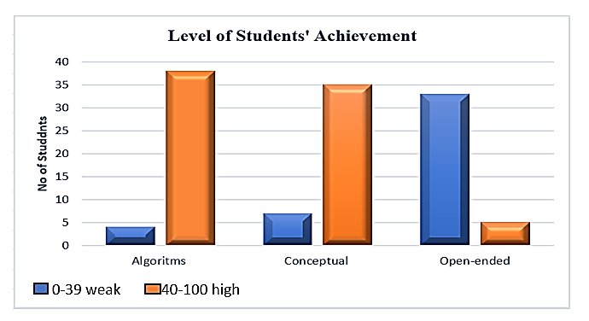
Figure 4. Level of students’ achievement in algorithmic questions, conceptual questions, and open-ended questions

Students are considered to have high marks for a particular type of question if they score between 40 to 100 marks, and low marks if they score between 0 to 39 marks. Among algorithmic, conceptual, and open-ended questions, it is evident that students face the most difficulty with open-ended questions, as the mean of students’ achievement in this category is the lowest.
Students tend to perform better on algorithmic questions because these questions typically require the application of a well-defined set of steps or procedures to arrive at a correct answer. The structured nature of algorithmic questions allows students to follow a clear path to the solution, reducing the cognitive load required to generate an answer. For example, in chemistry, algorithmic questions might involve calculating molar concentrations or balancing chemical equations, which are tasks that students can practice and master through repetition. This aligns with the findings of Ivony (2018), who noted that algorithmic questions often have a "yes" or "no" answer, or a specific numerical result, making them easier for students to tackle, especially those with lower proficiency.
On the other hand, conceptual questions demand a deeper understanding of the underlying principles of chemistry. These questions test students' ability to apply their knowledge to new situations, requiring them to connect different concepts and think critically. While conceptual questions do not always have a straightforward answer, they still often involve a more guided thought process compared to open-ended questions. Students may struggle with these questions if they lack a strong foundational understanding or if they are not accustomed to applying concepts in varied contexts.
Open-ended questions, however, are the most challenging for students, as they require the generation of original responses based on the students' understanding and interpretation of the concepts learned. According to Ivony (2018), these questions do not have a simple "yes" or "no" answer; instead, they require students to express their opinions, synthesize information, and articulate their thought processes in a detailed manner. This type of question often requires a longer, more elaborated response, such as a paragraph or essay, which can be daunting for students, especially those with lower language proficiency or less confidence in their understanding of the material.
The difficulty in mastering open-ended questions lies in the need for students to not only recall information but also organize and communicate their reasoning effectively. As Haiem et al. (2021) noted, while students are encouraged to provide as much detail as possible, they often struggle to align their responses with the expected answers. This discrepancy might be due to a lack of practice in structuring their thoughts or a limited ability to apply their knowledge in a less structured, open format. Moreover, open-ended questions often assess higher-order thinking skills, such as analysis, synthesis, and evaluation, which can be challenging for students who have primarily been trained in rote memorization or procedural problem-solving.
To strengthen the research findings, it is essential to incorporate insights from the respondents' interviews. Table 10 shows the response from five students via interview.

Table 10. The respondents' interviews.

Student | Response
Student 1 | · Algorithmic Problems: "I like algorithmic questions since I can solve them step-by-step. They are straightforward, and I usually score well."  · Conceptual Problems: "Conceptual questions challenge me because I need to think deeply. If I don't have a solid grasp of the concept, I feel lost."  · Open-Ended Problems: "Open-ended questions are the worst for me. I feel overwhelmed by having to come up with my own answers. I often write too little or get confused about what to include."
Student 2 | · Algorithmic Problems: "I find algorithmic questions the easiest because they follow a clear procedure. I can memorize the steps and practice them, which makes me feel confident."  · Conceptual Problems: "Conceptual questions are harder. I struggle to connect the ideas and apply them to new situations. Sometimes, I don't really understand what the question is asking."  · Open-Ended Problems: "Open-ended questions make me anxious. I don't know how to start or what to write. I worry about not being detailed enough."
Student 3 | · Algorithmic Problems: "Algorithmic questions are like puzzles; I enjoy solving them. I feel like I can rely on my skills and knowledge here."  · Conceptual Problems: "Conceptual questions require me to think critically, which is tough. I need more practice relating different concepts."  · Open-Ended Problems: "I find open-ended questions intimidating. I can’t express my thoughts clearly, and I'm afraid of getting it wrong since there’s no right answer."
Student 4 | · Algorithmic Problems: "I perform best in algorithmic questions. The rules are clear, and once I learn them, I can apply them easily."  · Conceptual Problems: "Conceptual questions are tricky for me. Sometimes I can answer them if I remember the class discussions, but it’s not always easy."  · Open-Ended Problems: "I really struggle with open-ended questions. I want to provide detailed answers but often end up writing less because I can't think of what to say."
Student 5 | · Algorithmic Problems: "I feel comfortable with algorithmic questions. They help me focus on calculations, which I'm good at."  · Conceptual Problems: "Conceptual problems make me think differently, and that can be hard. I wish we practiced these more."  · Open-Ended Problems: "Open-ended questions are challenging because they require creativity and articulation. I feel like I need more guidance on how to approach them."

From the response in Table 10, it is obvious that students expressed a sense of confidence with algorithmic problems due to their structured nature and clear procedures. Most felt they could master these through practice because they managed to answer the questions based on memorized procedures. Students generally found conceptual questions more challenging, often requiring a deeper understanding and connection of ideas, which they felt was lacking. Students managed to answer the questions only when they managed to relate the concepts learn to real-life examples discussed in class. However, when it comes to open-ended questions, there was a consensus that open-ended questions were the most daunting. Students reported feelings of anxiety, confusion, and difficulty in articulating their thoughts, indicating a need for more practice and support in this area.
The main limitations of this research include potential sample size issues, where a small or non-representative group may limit the generalizability of the findings to a broader population (Hennink, & Kaiser, 2022). Differences in problem difficulty, where algorithmic tasks might be easier or more familiar to students, can skew results, making it harder to assess true differences in problem-solving abilities. The influence of teaching methods, time constraints, and subjective grading of open-ended problems may also affect performance, leading to potential biases (Carpenter, Witherby, & Tauber, 2020). Moreover, factors such as student motivation, and prior knowledge may influence outcomes across problem types. It lead to complicate the interpretation of their true achievement levels in algorithmic, conceptual, and open-ended problems solving (Vo, Sarkar, White, & Yuriev, 2024).
In conclusion, the differences in students' achievement across these types of questions can be attributed to the varying cognitive demands each question type imposes. While algorithmic questions are more straightforward and procedural, conceptual questions require a deeper understanding, and open-ended questions challenge students to synthesize and articulate their knowledge independently (Bauer, 2019). By enhancing the analysis from interviews, the research findings can offer a more comprehensive view of the challenges students face and suggest targeted interventions to support their learning in chemistry.

4. Conclusions

As a conclusion to the findings of this research, there is a need for additional investigation into how to increase students' conceptual comprehension of chemistry concepts. As a consequence of this, it is wished that this study will in the future serve as a future guide and reference for additional researchers who do further investigation in this field. It is necessary to enhance performance in the solving of algorithmic problems, conceptual problems, and open-ended chemistry problems as well as the need to nurture a deeper conceptual understanding and improve students' capacity to generate responses that are both complete and well-organized. Besides, it can fulfill the objectives of KSSM such as appreciating chemistry and its application in helping to explain phenomena and solve real world problems. The ability of students to solve problems that are linked to chemistry was developed through a collaborative effort between the teachers and the students. In order to assist students in becoming better problem solvers, it is necessary for teachers to cultivate a culture of problem solving in the classroom. Students need to be placed in a learning environment that is based on students centered and in which they participate actively in the process of learning. If they are having trouble finding a solution to a problem, they should also have access to academic counseling. Teachers ought to always be willing to take chances in order to alter strategy and they shouldn't merely be linked to a learning strategy in order to improve students' ability to solve problems. Through this study, it is expected to help create a framework that can be used to promote problem-solving skills as well as scientific creativity among students.

References

Authority, S. Q. (2010). Chemistry open-ended questions support materials. Learning and Teaching Scotland.

Aziza, M. (2021). A Teacher Questioning Activity: The Use of Oral Open-Ended Questions in Mathematics Classroom. Qualitative Research in Education. 10(1). 31-61
.
Bauer, A. W. (2019). Understanding Problem Solving and Collaboration in Open-Ended Environments (Doctoral dissertation).

Bayarcal G. C. & Tan D. A. (2023). Students’ Achievement and Problem Solving Skills in Mathematics through Open-Ended Approach. American Journal of Educational Research. 11(4), 183-190

Black, P. (2018). Helping students to become capable learners. European Journal of Education, 53(2), 144-159.

Carpenter, S. K., Witherby, A. E., & Tauber, S. K. (2020). On students’(mis) judgments of learning and teaching effectiveness. Journal of Applied research in Memory and cognition, 9(2), 137-151.

Chophel, Y. (2022). Remediating misconceptions related to particulate nature of matter using video animation: An action research. International Research Journal of Science, Technology, Education, and Management, 2(1), 65-77.

Cracolice, M.S., Deming J. C. & Ehlert, B. (2008). Concept Learning versus Problem Solving: A Cognitive Difference. Journal of Chemistry Education. 85(6), 873

Fitriana, L.D., Fuad, Y. & Ekawati, R. (2018). Students’ Critical Thinking in Solving Open-Ended Problems based on Their Personality Type. Journal of Physics: Conference 947 012007. doi :10.1088/1742-6596/947/1/012007

Frank, D.V., Baker, C. A. and Herron, J.D., (1987). “Should students always use algorithms to solve problems?” Journal of Chemical Education, 64, 514-515

Frey, R. F., Brame, C. J., Fink, A., & Lemons, P. P. (2022). Teaching Discipline-Based Problem Solving. CBE—Life Sciences Education, 21(2), fe1.

Gagne, R.M. (1977) The Conditions of Learning, 3rd edn (New York, Holt, Rinehart and Winston)

Haiem, M. N., Cooke, J. E. & Kang, F. H. (2021). Students Strategies When Taking Open-Ended Test Questions Cogent Education, 8:1 , DOI: 10.1080/2331186X.2021.1877905

Haláková, Z. and Proksa, M. (2007). “Two Kinds of Conceptual Problems in Chemistry Teaching.” Journal of Chemical Education, 84 (1), 172- 174.

Hennink, M., & Kaiser, B. N. (2022). Sample sizes for saturation in qualitative research: A systematic review of empirical tests. Social science & medicine, 292, 114523.

Hurrel, D. P. (2021). Conceptual Knowledge Or Procedural Knowledge Or Conceptual and Procedural Knowledge: Why the Conjunction is important for teachers. Australian Journal of Teacher Education. 46(2).57-71.

Ivony, D. S. (2018). Students Difficulties in Answering Open-Ended Questions in Reading Comprehension Test: A Case Study At The Ten Grade Students of Ponpens Nurul Haramain NW Putri Narmada In Academic.

Kilpatrick, N. A. (2020). Student Understanding in Acid-Base Concepts in Chemistry: Conceptualization from General Chemistry II through Biochemistry.Dissertation, Geogia State University.

Malaysian Ministry of Education (2013). Malaysia Education Blueprint 2013-2025. Putrajaya: MOE.

Mayer, R. E. (2013). Problem solving. In D. Reisberg (Ed.), The Oxford handbook of cognitive psychology (pp. 769–778).

Nedjat-Haiem, M., & Cooke, J. E. (2021). Student strategies when taking open-ended test questions. Cogent Education, 8(1). https://doi.org/10.1080/2331186X.2021.1877905

Olubunmi, O. A. (2017). Effectiveness of problem of solving approach on gender related differences in teaching secondary school chemistry students mathematical concepts of chemistry in Ondo state, Nigeria. European Journal of Education Studies.

Rahmawati, Y., Hartanto, O., Falani, I., & Iriyadi, D. (2022). Students' Conceptual Understanding in Chemistry Learning Using PhET Interactive Simulations. Journal of Technology and Science Education, 12(2), 303-326.

Rau, M. A., Zahn, M., Misback, E., Herder, T., & Burstyn, J. (2021). Adaptive support for representational competencies during technology-based problem solving in chemistry. Journal of the Learning Sciences, 30(2), 163-203.

Rosa, V., Corrales, A., Nguyen, Y., & Atkinson, M. B. (2022). Relevance and equity: should stoichiometry be the foundation of introductory chemistry courses?. Chemistry Education Research and Practice, 23(3), 662-685.

Salame, I. I., Etwaroo, N., Khalil, A., & Kolozian, T. (2022). Examining Some of Students’ Challenges and Use of Algorithmic Problem-Solving Approaches in Electrochemical Titrations. International Journal of Instruction, 15(3), 465–482. https://doi.org/10.29333/iji.2022.15326a

Salame, I. I., Ramirez, L., Nikolic, D., & Krauss, D. (2022). Investigating students difficulties and approaches to solving buffer related problems. International Journal of Instruction, 15(1), 911–926. https://doi.org/10.29333/iji.2022.15152a

Sangguroa, S. A., & Surifa, J. (2019). A conceptual framework for enhancing problem solving skills in chemistry. Copyright© 2019 Universiti Teknologi Malaysia., 7.

Sausan, I & Saputro, S & Indriyanti, N. (2018). Chemistry for Beginners: What Makes Good and Bad Impression. Advances in Intelligent Systems Research (AISR), 157. Doi:10.2991/miseic-18.2018.11.

Shanta, S., & Wells, J. G. (2022). T/E design based learning: assessing student critical thinking and problem solving abilities. International Journal of Technology and Design Education, 32(1), 267-285.

Surif, J., Ibrahim, N. H., & Dalim, S. F. (2014). Problem solving: Algorithms and conceptual and open-ended problems in chemistry. Procedia-Social and Behavioral Sciences, 116, 4955-4963.

Tóthová, M., & Rusek, M. (2021). Developing Students’ Problem-Solving Skills Using Learning Tasks: An Action Research Project in Secondary School. Acta Chimica Slovenica, 68(4), 1016–1026. https://doi.org/10.17344/acsi.2021.7082

Tóthová, M., Rusek, M., & Chytrý, V. (2021). Students’ Procedure When Solving Problem Tasks Based on the Periodic Table: An Eye-Tracking Study. Journal of Chemical Education, 98(6), 1831–1840. https://doi.org/10.1021/acs.jchemed.1c00167
Tsaparlis, G. (2019). Teaching and Learning Electrochemistry. Israel Journal of Chemistry, 59(6), 478–492. https://doi.org/10.1002/ijch.201800071

Tsaparlis, G. (Ed.). (2021). Problems and Problem Solving in Chemistry Education: Analysing Data, Looking for Patterns and Making Deductions (No. 7). Royal Society of Chemistry.

Vo, K., Sarkar, M., White, P. J., & Yuriev, E. (2022). Problem solving in chemistry supported by metacognitive scaffolding: teaching associates’ perspectives and practices. Chemistry Education Research and Practice, 23(2), 436-451.

Vo, K., Sarkar, M., White, P. J., & Yuriev, E. (2024). Development of problem-solving skills supported by metacognitive scaffolding: insights from students’ written work. Chemistry Education Research and Practice.

Yaman, F., AYAS, A., & ÇALIK, M. (2019). Facilitating grade 11 students’ conceptual understanding of fundamental acid-base models. Turkish Journal of Education,8(1),16–32. https://doi.org/10.19128/turje.449100

