Experimental, DFT study, and in silico molecular docking investigations of dichlorodiphenyltrichloroethane against human estrogen receptor alpha

Tabe Ntui Ntui¹, Vincent Ndem Osabor², Peter Amba Neji¹, Michael Akomaye Akpe², John Akwagiobe Agwupuye²⁺, Stephen Adie Adalikwu³, Terkumbur Emmanuel Gber², Bitrus Hyelavalada Andrew², Uduak Ugbaja²

1. Cross River University of Technology, Faculty of Physical Sciences, Calabar, Nigeria.
2. University of Calabar-Nigeria, Department of Pure and Applied Chemistry, Calabar, Nigeria.
3. Cross River State College of Education, Akamkpa.

+Corresponding author: John Akwagiobe Agwupuye, Phone: +2348100056340, Email address: agwupuye.john@yahoo.com

ARTICLE INFO

Article history:
Received: November 09, 2021
Accepted: May 07, 2022
Published: July 01, 2022

Section Editor: Assis Vicente Benedetti

Keywords
1. DFT
2. molecular docking
3. DDT
4. estrogen receptor

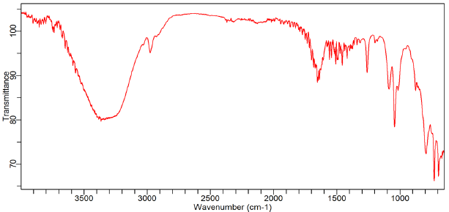
Figure S1. The ESI-Mass spectrum of dichlorodiphenyltrichloroethane (DDT).
Table S1. ADCH, HPA, BPA and MPA result of DDT.
Atoms | ADCH | HPA | BPA | MPA
C | 0.0957 | 0.1321 | 0.6365 | -0.2842
C | 0.1777 | -0.0175 | -1.1844 | -0.2833
H | 0.0929 | 0.0392 | 0.0717 | 0.1909
C | -0.4344 | -0.0101 | 1.8669 | 0.1801
C | -0.2849 | -0.0315 | 0.4992 | -0.1513
C | 0.1021 | -0.0369 | -0.9841 | -0.1694
C | -0.0902 | -0.0414 | 0.3357 | -0.1334
H | 0.3078 | 0.0409 | -0.7734 | 0.1491
C | -0.1675 | -0.0429 | -0.1831 | -0.1292
H | 0.1019 | 0.0435 | 0.1667 | 0.1465
C | 0.1569 | 0.0293 | 0.2059 | -0.0629
H | 0.1153 | 0.0531 | -0.1346 | 0.1607
H | 0.1457 | 0.0531 | 0.0220 | 0.1602
C | -0.2301 | -0.0048 | 1.1507 | 0.1756
C | -0.1779 | -0.0341 | 0.2824 | -0.1718
C | 0.5055 | 0.0408 | -3.6223 | -0.1747
C | -0.0821 | 0.0409 | -0.1093 | -0.1254
H | 0.1251 | 0.0479 | 0.0671 | 0.1417
C | -0.2409 | -0.0407 | 0.3509 | -0.1330
H | -0.1773 | 0.0332 | 1.9935 | 0.1603
C | 0.0014 | 0.0278 | 0.3894 | -0.0635
H | 0.1409 | 0.0536 | 0.0787 | 0.1607
H | 0.1367 | 0.0532 | 0.1088 | 0.1611
Cl | -0.0631 | -0.0517 | -0.2071 | 0.0373
Cl | -0.0569 | -0.0520 | -0.2055 | 0.0475
Cl | -0.0343 | -0.0332 | -0.2737 | 0.0418
Cl | -0.0664 | -0.0619 | -0.2387 | -0.0157
Cl | -0.0971 | -0.0616 | -0.3100 | -0.0157

